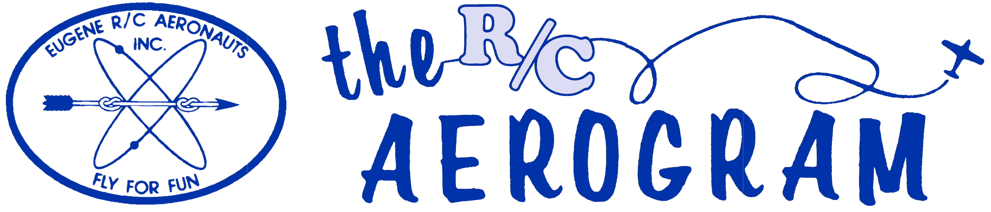

Volume 4 Issue 4 AMA #530 District 11 www.eugenerc.com April 2008

Club Mailing Address: Eugene R/C Aeronauts, PO Box 26344, Eugene, OR. 97402

ERCA News and Information

Next CLUB Meeting – April 22, 7:00 pm at EWEB. If you have a building project, bring it with you for "Show and Tell".
At the March Meeting – We ate PIZZA! 39 members attended the March Pizza meeting. It is amazing what a little food will do for turning out a crowd!
Khoi’s Corner – This month was a bit of show and tell around the Byron Originals F-16 ducted fan Khoi and Frank are assembling. Along with the equipment and construction details we were advised of an inexpensive, fuel proof finish for out projects. Khoi and Frank have been using Krylon spray paint and MinWax clear polyurethane finish spray. This is available in gloss, semi-gloss and satin finishes.
Show&Tell – Mark Stafford has caught the helicopter sickness and has three electrics he’s been flying at home and he brought two of them to show.
Jacob Blewett brought his new T-Rex 600 heli and Spectrum dx7 radio.
Alan Peacock shared a tip for precision oiling or gluing by using inexpensive syringes available at feed store etc.
The updated By-laws and Constitution were presented for the first reading, with vote on approval to be at the April meeting.
Items debated and approved by majority vote:
-- Smoking at the field is allowed only inside a vehicle.
-- Active duty members of the military (defined as full time service or active reserve/national guard member) will be granted free membership and waived initiation fees upon their request. Membership status will be reviewed on a yearly basis for eligibility.

Our PO Box has changed to: P.O. Box 26344, Eugene, Or 97402. Any OFFICAL ERCA mailings should be sent to this mailing address.
CARL HENSON FIELD – Carl visited the field April 3rd, there was a small crowd flying and chatting. Before leaving he told me that it was a good visit for him.
The field was mowed a several times in March and April. Seems that the mowers were not all that willing to behave in March, as each decided to break a belt, so far in April they seem to be less temperamental.
The field access road was graded at the end of March.
There is a drawing on the club house bulletin board of the "designated flying area", PLEASE look it over.

Meeting minutes are ONLINE at: http://erca.home.comcast.net/%7Eerca/Meetings.html

LATE BREAKING NEWS - See Section B in the Tuesday April 15th Register-Guard

FLYING SITE RULES

EUGENE R/C AERONAUTS AIRPORT for MINIATURE AIRCRAFT

FLYING SITE RULES

1. Spectators must remain behind fence.
2. Use of field restricted to club members and guests.
3. Current AMA license required.
4. No power flying before 7:30 a.m. *
5. Transmitters are not to be used without frequency clips.
6. Transmitters not in use must be placed in impound area.
7. All transmitters must be certified narrow band operation.
8. Quiet Mufflers required for all 2-cycle engines.
9. Smoking allowed only in vehicles.
10. No pets allowed.
11. No flying over spectator areas or pits.
12. No excessive running of engines in the pit area.

As Posted at Flying Site on October 24, 2005

* WINTER FLYING – During November, December, January, February Saturday, Sunday & Wednesday flying time start is 12:00 Noon.

Also - The flying area for our club has now been defined, as voted on by the membership at the June 2007 meeting. As always, there is NO flying over the pits area or vehicles. Aircraft can fly to the north of the runway's south border as far as the eye can see. Aircraft can fly south of the runway only when west of the runway's west end. An exception is in place for helicopters and electrics utilizing the heli-pad.

The “Field Rules” sign on the end of the club house will be updated soon, as well as printed copies on the bulletin board inside. Please take a copy and read it. If you have any questions about the RULES, ask one of the Safety Officers / Field Marshals to clarify them for you. One simple rule not on the list is “When in doubt – DON’T!”
At the last meeting -- A lengthy discussion of the use of common courtesy while flying took place.
Make sure you communicate your intentions – yell loud enough for everyone to hear - to take off, land, enter the runway area etc. Helicopters - hovering, sharing airspace and the use of green paint to cover the brown spots in the field caused by hot exhaust was covered extensively as well.
A review of the AMA general safety rules is recommended to refresh your memory.
A reminder to all using multiple radios, please, check out one frequency pin at a time.

WHATS NEW

Updated Insturctors List (aka Flight Trainers - Intro Pilots)

Our R/C Flight Trainers

These ERCA members are willing to assist you through the learning curve.

AMA Instructor pilots

John Bowhan 607-5752
Roger Dahl not available at this time
Doug Devereaux Florence 1-541-999-1844
Scott Fellman 913-3549
Bill Hollingsworth 689-1478
Chuck Jenkins 736-5148
Larry Nielsen 998-1616
Rich Richardson 736-3008
Khoi Tran 685-0086
Alan Wellentin 726-7482
Dale Williams no current phone number
Pat Willis 543-8999
Marty Wittman 968-2094

As of the publishing of this newsletter - Instructors underlined have confirmed their willingness to be on a list handed out to prospective members.

FOR SALE

The Carl Goldberg Ultimate 10-300 -- In last months newsletter has SOLD!

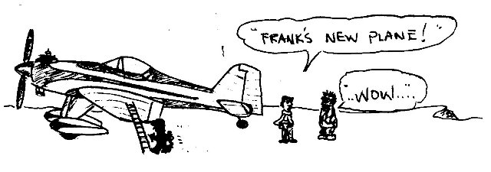

Field Marshals Corner

Safety Tip:
When you're in the pits (not flying), and you see another pilot starting their engine(s) help them out! Another hand or two on the aircraft--usually around the tail feathers--is not only safer, but it's also a common courtesy to your fellow pilot!

Bill Hollingsworth
Field/Safety Marshall

Treasurers Corner

2008 Jan 34 members have paid their dues.
1 new member joined this month.

2008 Feb 58 members are confirmed current with AMA and ERCA.
2 new members joined this month.

2008 Mar 87 members are confirmed current with AMA and ERCA.
3 new members joined this month.
Thanks to everyone for their prompt renewals.

Our PO Box has changed to: P.O. Box 26344, Eugene, Or 97402.
Any OFFICAL ERCA mailings should be sent to this mailing address.

From the Secretary / Treasurer's desk:
As of this writing the club is at 86 members with several more scrambling to renew for 2008 believe it or not. I spent a lot of time calling and tracking down members who had not renewed in order to verify their intentions before deleting them off the roster. This delayed getting the club's charter and insurance renewal to AMA by the deadline of March 31st. At the last moment before the deadline I faxed and paid the necessary documents and fees to prevent a break in our insurance coverage. I am following up late with the club's final updated roster which is still in a state of flux.
The 13 Introductory Pilot Program Instructors should be receiving their 2008 packets soon. Review the criteria and requirements. There are provisions now to do the Student registration online at the AMA website. www.modelaircraft.org

Happy Landings

AL Barrington
Sec/Treas, ERCA

1980s Newsletter Banners

Newsletter's new “RETRO” Banner – Looking over a lot of ERCA newsletters from the past, some from the 1980's inspired me to construct the new banner. I hope you like it!

1982 May
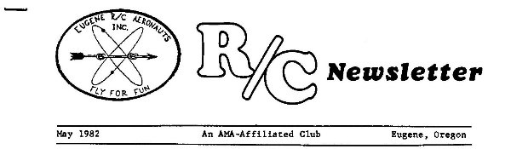

1984 Dec
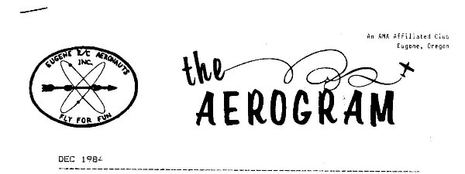

1987 Jan


1987 Feb
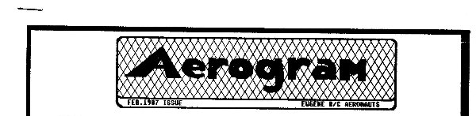

1987 Apr
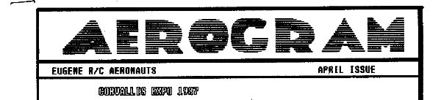

1987 May
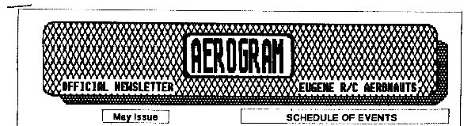

1987 Sep
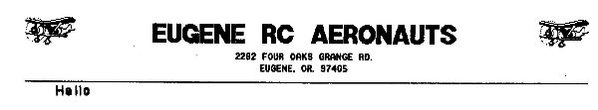

1988 Feb
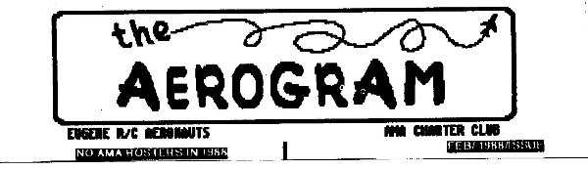

1989 Sep
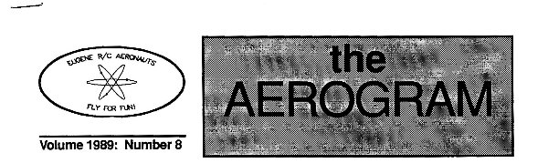

2003 Aug


2005 May
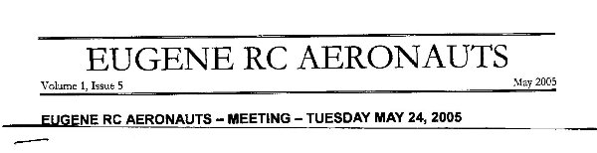

2008 Feb
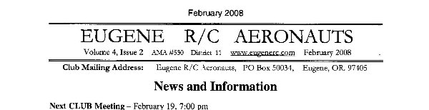

Presidents Corner

I don't know about you, but every weekend I anxiously check the weather forecast to see if I may get a couple hours of time without hurricane-force winds or downpours. Unfortunately, those opportunities have been few and far between lately with Mother Nature making up for a somewhat dry Fall. I'm hoping that I will start getting more chances to buzz around the flying field in the coming future, and hopefully I'll see you there!

A couple weeks ago some folks got to witness how your club president reacts when he crashes his helicopter. I think they were surprised and maybe a little perplexed when I laughed after my little T-Rex 450 hit terra firma at a high rate of speed and descent. The white plastic canopy broke into tiny pieces and gave the illusion of a small snowstorm over a muddy mess of broken plastic and metal parts. Really, it was no laughing matter, but if I let myself get upset about it, I would not have been able to enjoy the rest of the flying day. I was having so much fun with that little rotary bird before it happened that I at least felt like it was worth the amount it would cost to fix it.

Okay, back to fixed wing! I'm looking forward to seeing all of your new projects that have been taking shape during the past several sour weather months. I've heard rumors of some nice scale projects coming along and I can't wait to see them... even the Piper Cubs and Mustangs!! I personally do not have any new fixed wing aircraft to play with. After I crash a few, I'll have enough room to buy a new one, but until then I'll keep flying my 33% Yak 54 and 29% Giles G202. The Yak flies so well that I just cannot imagine being satisfied with anything else now. It's funny to think that the full-scale Yak 54 is apparently somewhat of a heavy, under-powered dog according to the full-scale aerobatic pilots' gossip.

I'll leave you with some comments about recent issues brought to my attention by your fellow flyers. First of all, smokers can only smoke in their vehicles now. This was decided by the membership at the most recent meeting. This is not negotiable and it is in effect all year round. I know that some of you are not going to like that, but the membership spoke, and it's now a rule you are expected to follow whether you agree with it or not. Second, no pets are allowed at the field, NO PETS AT ALL! It's in our lease, it's in print on the sign on the side of the clubhouse. No exceptions.

May your take-offs be swift and your landings soft...

PATRICK WILLIS
ERCA PRESIDENT 2007-2008

FOR SALE

The Hanger 9 Tribute with a Magnum 46 -- In last months newsletter has SOLD!

The 1/4 scale J3 Cub and U-CAN-Do 3D have SOLD!

WITH THE WEEKDAY WARRIORS - April 2008

Could Spring actually be arriving? I know; an Oregon Spring is nothing to write home about, but a few good days do sneak in from time to time.
We’ve seen plenty of helicopters on the weekdays lately. Pat Willis had two out one day - both T-Rexes, a 600 nitro and a 450 electric. I think the 450 is sort of a guinea pig on which Pat tries out things he’s not yet rash enough to attempt on the larger, more expensive 600. On this day, the 600 was undergoing some revision and was not flyable. Pat brought it out as an example for Jacob Blewett who has acquired one. Jacob’s didn’t fly that day either, because it transpired that the clutch was set up far too tight, a problem correctable only in the shop. Pat’s 450 hit the dust during the morning, an apparent case of zigging when he should have zagged.
Scott Fellman has something different - Hirobo Skidoo 50s - and he has progressed to flying circuits with them. Yes, it is certainly possible to distinguish an Hirobo Skidoo 50 from a T-Rex 600. Well, there are the name decals on the canopies for one thing.
No shortage of models with their wings screwed on firmly, either. (Note that I didn’t say, “as they should be”- restraint is my middle name) In fact Pat had his Yak 54 with the 3-W 70 engine and he thinks that this is the best model he has ever flown. Jacob was flying a cowl-less Extra 300S, which I think is ex-Frank Blain. Do you know that 0.S. 50s run just fine with the cylinder-head fins running crosswise? Jacob was satisfying his curiosity about what was inside the cylinder and put the head back on 90 deg out of whack. Some engines won’t even let you put the head on that way, let alone run well!
Frank Blain himself was on the field with yet another Yak 54, his with a Fuji 43 gas-burner for power. All was well until Frank essayed a takeoff from north of the runway centerline and hit a long strip of very mushy ground. It grabbed the wheels and their pants and flipped the big Yak right on its back without a pause for breath. Some small damage to the cowl and its fastenings and the thorough destruction of one of those large, expensive props that make flying the big birds so much fun.
Joe Kizer has had a year-and-a-half layoff, but was on the field one day with a Pizzazz, powered by a Magnum 52 sporting a vivid purple cylinder head. His intent was to scrape some of the rust off his flying technique. It appeared (to your columnist at any rate) that the rust was indeed flaking off and that the Pizzazz would go home in the same shape as that in which it had arrived.

The Bellanca Decathlon is a version of the Citabria, tuned even further than that plane for aerobatics. Chick Foster’s model Decathlon was flying very well and had him well-pleased. He doesn’t have it anymore, because a guy came along and threw so much money at him that Chick was more than pleased to sell the model.

Doug Deveraux made the long trek from Florence with a rebuilt and somewhat modified Funtana whose power is one of those Evolution 46s. Doug is quite happy with the engine and it seems to me that other Evolution owners feel the same way. Rich Richardson was flying a couple of electrics (What else?), but these were from a commercial line, not from his stable of own-designs. My notes are inadequate, but I seem to remember that they were a Pico Stick and a Big Stick (Stik?). Rich had improved them with the ample turned-up tips he has on the wings of his own ships.

Chuck Jenkins has a goodly supply of old model stuff around his place and one day he turned up with a Fledgling. This is an old. old, even ancient, trainer, from Topflite, if memory serves. (Was Harding President then, or was it Coolidge?) The kit was put out with a tricycle gear, but Chuck’s is set up on two mains and a tailwheel. He had brought it out to let Morris Ostrovsky fly it while his model was under repair.
Speaking of Mr. Jenkins, I was informed that he was in the hospital over in Springfield. I set out to see how he was getting along since he does provide so much grist for this column to mill over. I’d never even seen the Springfield hospital before, but I did find it and, eventually, a parking space. Then I had to find a way in, but the most promising door said, “Emergencies Only” and another sign said, “The Ambulance Will Get You, If You Don’t Watch Out”, or words to that effect. Indeed, there was an ambulance right there, just waiting for me to put a foot wrong. I got in via a back door behind some bushes and later discovered the front desk. Asking for “Chuck Jenkins” produced blank looks until a few computer operations revealed that he had been renamed “39-Window”. I even found Room 39 and, yes, there was a window - and a bed and a young girl mopping the floor, but nothing resembling Chuck Jenkins. I mean, he would have stood out, right? Another desk and more computer-punching brought forth the news that “39-Window” had scampered a mere 45 minutes before. Now it seems to me that that’s good news, but, the next time I see “39-W”, I intend to take him to task for not sticking around at least long enough for me to say, “hello”. (N.B. If his view of hospitals is the same as mine, he’d not have stayed an extra two seconds, even on the promise of a visit from Raquel Welch, so I’d be wasting my breath, wouldn’t I?)
C.O'D.

AIRPLANE DONATION REQUEST

Got an aircraft collecting DUST?
Our “10 MPH” sign has survived a couple wind storms, hail and snow.
The sun, rain, birds and some bird shot have taken their toll on it.

The "Emerald" below was donated and installed by Bill "Kill Bill" Hollingsworth.

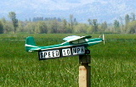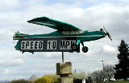

April 2006 April 2008
Any type of aircraft that will not over-stress the post it is mounted on will do.
Fixed wing or rotating wing will do fine.
Email james.corbett@comcast.net

KUDOS

A GREEN THUMB award to Richard King and John Oster for their generious donation of High Quality fertilizer.
Thanks to the “MOWER UN-BREAKING GROUP” - Doug, Chuck and Jim (aka MUGs) for re-belting both mowers recently..
Also lets thank the GRADER GUY! The road looks much better.

This newsletter can be viewed ONLINE at: http://erca.home.comcast.net/%7Eerca/NL/ERCA_NL_APR08.pdf

WANTED

Subject:: Looking for vintage r/c radios, engines and tether cars for my collection
My name is Michael Diamond and I have been an active R/C flyer since 1969 (AMA 55859). I am presently building a collection of vintage R/C radios, engines and tether cars and am writing to inquire if any of your club members may have any old radios or engines that they would like to sell
I am looking for radios, engines, and tether cars from the 1940’s to 1980’s and will buy 1 item or an entire collection.
My contact information is as follows:
Michael Diamond, 2784 Great Smokey Court, Westlake Village, CA 91362
Tel: 805/496-7656 e-mail: dgem@earthlink.net
I would appreciate it if you would pass this request along to your club members or possibly post it in your club newsletter if that would be possible. Thank you in advance for your assistance. Sincerely, Michael Diamond

This newsletter can be viewed ONLINE at http://erca.home.comcast.net/%7Eerca/NL/ERCA_NL_APR08.pdf

--- That's All Folks ---

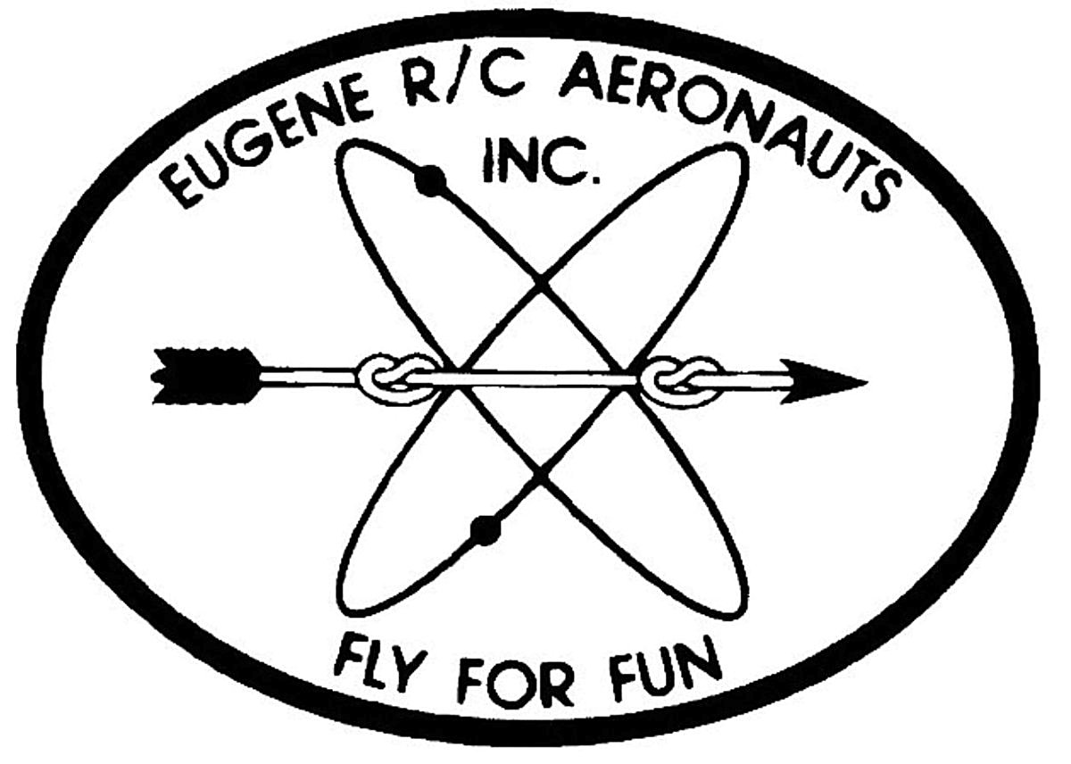
Eugene R/C Aeronauts
Newsletter Editor
1618 Gilham Rd.
Eugene, OR. 97401

APRIL 2008

Name

Address
City, ST Zip

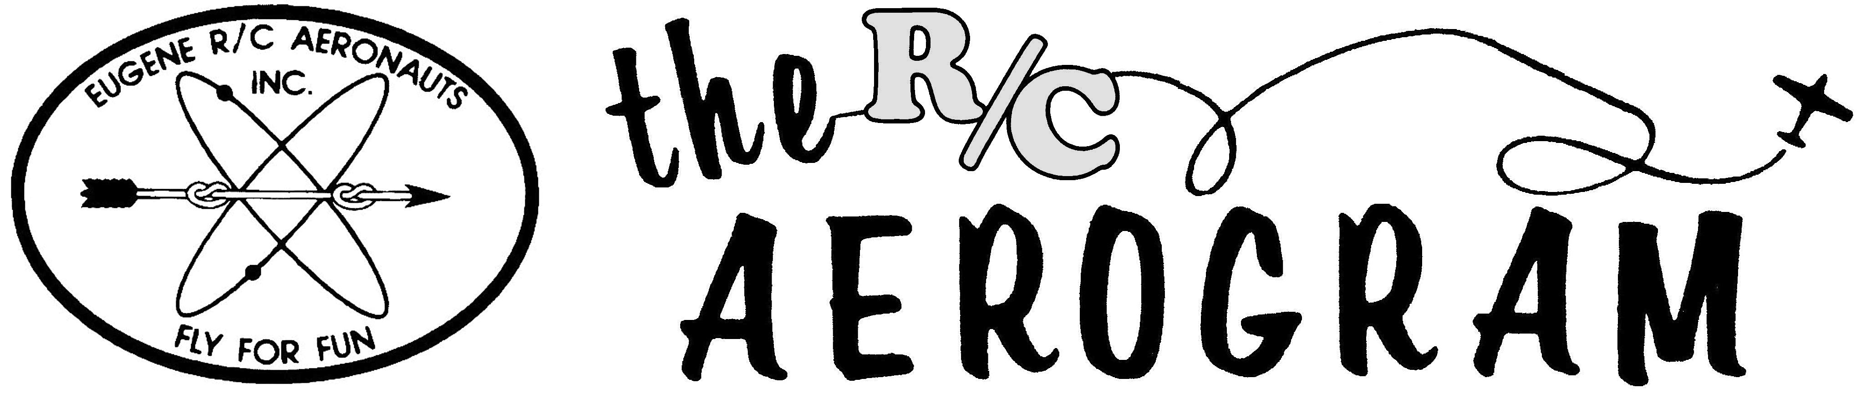

ERCA CLUB CONTACTS

President: Pat Willis – 543-8999 - p-willis@msn.com
Vice President: Mel Thompson - 746-5699 - met324@comcast.net
Sec/Treasurer: Al Barrington - 935-4960 - albarrington@msn.com
Groundskeeper: Doug McWha - 741-3326 – flyduke@comcast.net
Field Marshals: John Bowhan - 607-5752 - jbowhan@epud.net
Frank Blain, Jim Corbett, Bill Hollingsworth, Khoi Tran, Alan Wellentin
Newsletter Editor: Jim Corbett - 344-5022 - james.corbett@comcast.net

Newsletter ONLINE at: http://erca.home.comcast.net/%7Eerca/NL/ CURRENTNEWSLETTER.pdf

