EUGENE RC AERONAUTS
Volume 3, Issue 12 www.eugenerc.com December 2007
Club Mailing Address: Eugene R/C Aeronauts, PO Box 50034, Eugene, OR. 97405

No December Meeting

DUES TIME
2008 is coming, PLEASE pay your AMA and ERCA dues EARLY!
Consider this list for your 2008 RC goals:
1. Pay AMA Dues 2. Pay ERCA Dues 3. Buy NEW Tx and Rx bats.
(Give list to Santa)
You will get this Newsletter for a couple months,
then if you are not a current member it will stop arriving.

CLUB AUCTIONS – We will be holding a club auction at some of the meetings. If you have anything to sell or give away bring it to one of these meetings. You can set a minimum sell price, be realistic or you will pack it back home. 10% of the selling price goes to the club. The auctioneer will set the rules. This would be a good time to dispose of those items that have been accumulating dust and help the club treasury.

Attention RC Pilots:
WINTER FLYING RULES
During November, December,
January, February
Saturday, Sunday & Wednesday
NO FLYING before 12:00 Noon.

CARL HENSON FIELD – Just as a reminder, we will be holding our club meetings for the month of June, July and August at the field. We encourage everyone to come early and fly. We plan on having BBQ’s at the field meetings and will keep you informed. A couple of items for all members – Please make sure that you once you enter Mike Burgess’s drive to our club that your speed is less than 10 MPH. Simply drive slow enough that you are not seeing dust. Field trash – No trash period – this includes cigarette butts. If you see trash pick it up. Also, every now and then you may find that another member has left the field and forget to pack up a tool, glow plug starter or whatever. If you find anything at the field and you know it’s not yours please put it in the clubhouse FOUND basket. The person that left it and returns to find it will be grateful.

FUN FLY’S OR OTHER EVENTS – We have brought this up at several meetings. If you would like to participate, why not take the lead and set one up. Any member can do this and we encourage new members to step forward and become active.

PIZZA MEETING
Club approved having the March 2008 meeting at Papa’s Pizza on Coburg Road.

NEWSLETTER NEEDS INPUT – As your new newsletter editor, I will be relying on INPUT from the Officers and Members. I work Tuesday nights and can not attend meetings, so I will have to rely on others to be my “eyes and ears” at the meetings and flying field. My approach will be to keep the Printed and Mailed version small enough to only need ONE stamp. The EMAILed version can be as elaborate as we want. I am requesting that members send me photos and a short write-up on any projects they are working on, or new aircraft. If you can’t email it to me, mail me a photo and a note. Also if you have any TIPS or EXPERIANCES you would like to share, I would be glad to pass those along.

My thanks to Bill for the great job he did on the newsletter last year!

PLEASE
IF you have an EMAIL account,
PLEASE request your Newsletter via EMAIL.
STAMPS and PAPER
cost the Club (YOU) money.

WHATS NEW

Whats New at: http://www.eugenerc.com/

New "Khoi's Corner" page up and coming!
For more info, click here: http://www.eugenerc.com/khoi.php

Proposed at Novembers meeting was a new segment named simply, "Khoi's Corner" in effort to spur a higher member turnout at the meetings. Khoi will be bringing his and others' building techniques from his workshop to the meeting that will help the new members, and hopefully bring interest to the ol' timers of the hobby. He will be inviting members in who in which he feels has something to really add to the community of builders here at ERCA.

As I know many of you can't always make the meetings, or just want a refresher course of something you saw or learned, I will be providing a full coverage of many of the building tips offered at the meeting. This idea is still in the workshop but I think it will greatly help many of our members. Stay tuned!

Kevink@eugenerc.com

TIPS & TECHNIQUES

Plastic Screw Holding – Works for Flat, Phillips and Allen head screws.
Light a candle and dip the tool tip in the melted wax, let it cool a bit then place the waxed tip in the screw. It will stay on the tool until you get it where you want it to go…

Retrieving dropped screws – or other items – Place a waded up piece of tape (sticky side out) on the end of a screw driver, ruler or other object and press against the dropped item. You do not need a plastic magnet to retrieve those plastic parts….

Got a TIP to share, PLEASE pass it along…

WITH THE WEEKDAY WARRIORS - November 2007

The Gray Pathetic Northleft is, as I type, treating us to a third consecutive day of rain. The fog, too, has been a regular visitor to the field and has hung around into the afternoon. It disperses only when it is sure there’s enough wind to plague us.

Despite all that, there have been a number of flyable days which nobody seems to have taken advantage of. I have been to the strip on a Tuesday, a Wednesday, and a Thursday and have had it all to myself. In two cases, the wind was almost nil and it wasn’t too bad on the third day, either. Am I getting there at the wrong time? The Wednesday, at 12:45, had seen the fog depart and more than just a hint of sun to be seen.

Having the field to myself gave me the opportunity to throw hand-launched gliders out on the runway where the footing is better, resulting in stronger launches. I converted my He-Man HLG to a configuration optimized for sidearm throws instead of overhand which conversion requires a complete rearrangement of the tail assembly and a new fuselage to accommodate the rearrangement. I was getting the feel for how steeply I could launch and just where the release point should be in relation to the wind when my He-Man met an untimely end. It is quite shocking how badly a model will behave when it has been given a good sidearm toss right after the fin has fallen off at the launch site. The noseweight survived, as did the stabilizer, and, of course, the fin which hadn’t taken part in the crash at all. Add another to the list of Winter projects, because things looked promising.

One of the few I have caught at the field is John Byrne. John had a foam (I think) electric Piper Super Cub. A medium-size ship with flexible, plastic wing struts which clip on to the wing but are held with a screw to the fuselage. They are, presumably, functional. And they do work. Somehow, John got the ship into a full-bore vertical dive and recovered by means of a 90 degree pullout at an altitude of about three feet. It all stayed together - and the elevator must be pretty effective, too. John was taking off very nicely from the ‘electric runway”, but I couldn’t talk him into trying a landing on it.

One thing concerns me about John’s Cub. The transmitter says it’s on 27.195 mc. That’s okay; the 27 meg channels are still kosher and probably as safe as any channels now that all the inane chatter from the CB radios has apparently been transferred to cellphones. We have no pins for 27 meg.. This ship flies quite well and could become popular. Are they all on 27.199? The transmitter is also marked “channel 9’, but where did that come from? Channel 05 is 50.90mc. in the Ham band. And I think I may have seen another guy taking one out of a car as I was leaving one day.

Jim Corbett was not only taking off from the wooden runway; he was landing on it. He had a small, electric, swept-wing bipe called a Wildfly. Not all the landings stayed on the runway, but I did see one that managed to stop before the runway ran out. The battery installation on this bird is not what could be called elegant; the battery is just strapped to the top of the cowl. It is, however, practical. Very easy to get at for charging and even sliding back and forth to make subtle changes in the balance, depending on how wild Jim wants to fly.

Having mentioned cellphones as I did above somewhere, I will now impart another piece of cellphone news. You are aware, no doubt, that Doug McWha was the only one on the field classy enough to have a phone that played Mozart when it rang. Well, that phone was a couple of years old and, thus, near-prehistoric by electronic standards, so Doug traded it in for the newest thing. The new one not only does phone conversations, but also lets you send e-mail (which the recipient won’t receive) and lets others send e-mail to you (which you won’t receive). It also takes pictures which will go astray if you transmit them to another person and allows you to plug the phone into your computer (which then tells you it doesn’t know you and will you please go away). I got all this information from overhearing bits and pieces of conversations at the field between Doug and Jim, so I may not have all the details exactly right. It does, though, sound all quite modern. And Doug has stuck with the classics; this new phone plays Rossini.

I hope none of you was passionately enamored of Daylight Saving Time, because I moved the clock in the trailer back one hour. That’s what comes of me being all alone at the field, having busted my glider and with nothing else to do.

Come January, Jim Corbett will be your new newsletter editor - unless he flees to the Corvallis club and asks for asylum. This column, which is produced on one of Johannes Gutenberg’s original presses, then has to be rolled up and put into the little cylinder attached to the pigeon’s leg. The pigeon then has to get all the way over to Bills house in darkest West Eugene, a trip that involves a trans-Willamette over-water flight. As of January, the poor bird has only to go up a few blocks and turn left. Should simplify things no end.

C. O’D.

FOR SALE

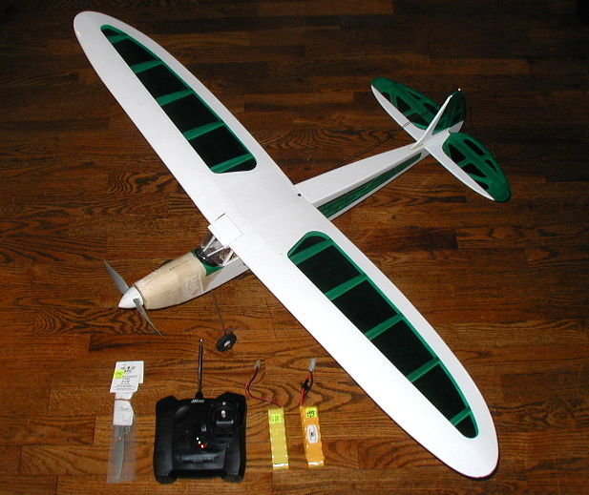
This is a Radio Controlled, Electric Powered, Ready-to-Fly Rascal.
Needs: Charger to charge the 7 cell (8.4v) NiCad battery packs
Purchase costs exceeded $340 Make an offer.

james.corbett@comcast.net 344-5022

Gripes & Grumbles

Door key disappearing.
Wish people would LEAVE WITH their TRASH.

KUDOS

DougM - Thanks for the SHORT GREEN!
ChuckJ - For the electrical expertise keeping the lawn mowers SPARKING!
FrankB - First Class table builder!
C O'D - For providing great color in black & white.
BillH - Newsletter and getting some young ones interested.
PatW - He kept us growing and improving.
All the INTRO PILOTS - We need each of you to continue to add members.
AND the Members that do not leave trash behind!

2007 in Review Go to the web page to see higher quality pictures
http://erca.home.comcast.net/~erca/NL/ERCA_Newsletter_Dec07.htm

January
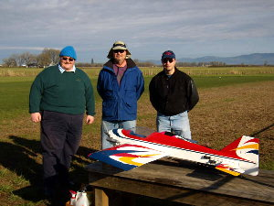
New Officers Al, Bill, Pat
February
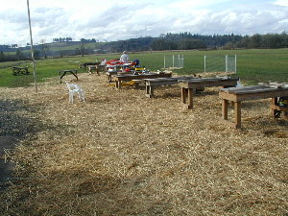
Straw down
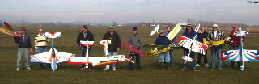
Super Bowl Sunday Crowd
March
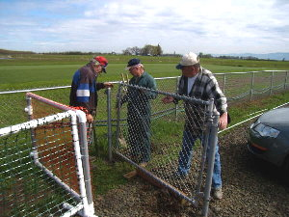
Gated water supply
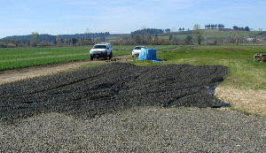
More parking West
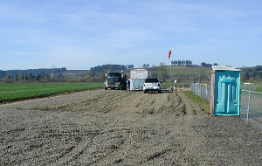
More parking East

April
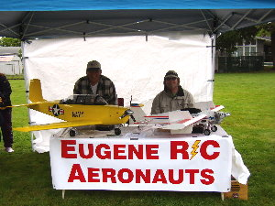
Scouts get RC flight offer
July
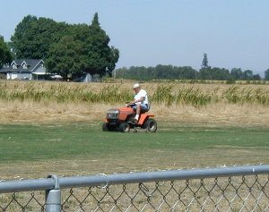
Green and short
September
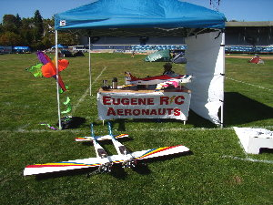
Scout-a-Ganza booth
October
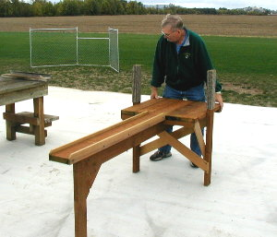
Cool - New pit tables
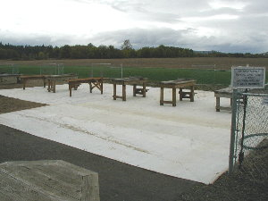
Pit area mat laid down
Ready for the RAIN
(slick when icy)

2007 in Review continued

Excerpts from ERCA Meeting Minutes

January 23, 2007
Discussion on graveling a larger parking area. An auction to be held at the field in June with a meeting / barbecue. Gary and Rex said they would like to put on a Pattern Flyer / Sportsman Primer. The club decided to conduct the event on Saturday, May 12th.
February 28, 2007
Big Bird fly-in will be on March 31St weather permitting. Club voted to purchase another load of sand for $200.00. The sand will be spread on the runway.
March 27, 2007
Frequency pins needed for 2.4 ghz radio transmitters. “Spread spectrum”. Pat said we need four more intro pilots. Pat nominated Frank Blain and Khoi Tran. We still need two more intro pilots to bring the total number of intro pilots to ten.
April 24, 2007
Bill said Dale Williams and Larry Nielson have been added to the intro pilot roster. This reaches the club‘s goal of having ten intro pilots. A banner was purchased for $62.50 from Signs Now that says Eugene R/C Aeronauts. A new box has been placed under the radio rack to be used for “lost and found” items at the field.
May 22, 2007
Pat suggested that ERCA may have to think about imposing a cap on the number of club members because of lack of room for parking and flying and club resources in general. Pat also mentioned the that the club may want to think about opening up a second field. John Bowhan made a motion to build six more field flight-tables. $350 was approved for the material cost. Bill said that fire season starts June 1st. All smoking will be inside vehicles until the end of fire season. Al Peacock suggested that a sign should be made informing smokers of the smoking rules.
June 26th, 2007
Pat said that the club seems to think that a membership cap was not a good idea. Doug made a motion to revisit the issue when the club reaches 120 members. Frank made a motion, and club approved, to put two loads of gravel on our part of the road. After much spirited discussion about flying boundaries, the club agreed that the boundaries are: the south edge of the runway to an easterly direction of infinity. The westerly boundaries are as follows: the south edge of the runway, which then makes a southerly L shape to infinity. The heli pad area and toward the direction of the west end of the runway is forbidden for fly over by glow-powered, fixed-wing aircraft.
July 24, 2007
John Bowhan reported to the club that he researched the AMA style tables. Material cost for each table is $50.00 Club approved construction of six tables at a cost of $320.00 frank Blain offered the use of his garage workshop for construction of said AMA style tables.
September 25, 2007
Five AMA style flight benches were constructed by Frank Blaine/ John Bowhan. Three more are in the works. Doug McWha procured some conveyor belt material which will be laid down in the pits to help control mud problem during rainy season. Some people are smoking outside of their vehicles; Pat reminded the club that all smoking must be inside of vehicles until the end of October.
October 23, 2007
Club agreed that club dues must be paid up front in one payment for renewing members. New members can make three separate payments of one-third of the balance due, but must be paid in full by the March ERCA meeting.

Nominations of ERCA officers:
President: Pat Willis, Khoi Tran
Vice President: Scott Fellman, Mel Thompson, Khoi Tran
Secretary/Treasurer: Al Barrington
Field Marshals: Frank Blain, John Bowhan, Jim Corbett, Bill Hollingsworth, Khoi Tran, Alan Wellentin
Newsletter Editor: Jim Corbett
November 27, 2007
Club approved having the March 2008 meeting at Papa’s Pizza on Coburg Road.

Election of ERCA officers:
President: Pat Willis,
Vice President: Mel Thompson
Secretary/Treasurer: Al Barrington
Field Marshals: Frank Blain, John Bowhan, Jim Corbett, Bill Hollingsworth, Khoi Tran, Alan Wellentin
Newsletter Editor: Jim Corbett

Club Contacts:
President – Pat Willis – 543-8999 - p-willis@msn.com
Vice President - Mel Thompson - 746-5699 - met324@comcast.net
Sec/Treasurer – Al Barrington - 935-4960 - albarrington@msn.com
Groundskeeper – Doug McWha - 741-3326 – flyd@clipper.net
Field Marshals - John Bowhan - 607-5752 - jbowhan@epud.net
Frank Blain, Jim Corbett, Bill Hollingsworth,
Khoi Tran, Alan Wellentin
Newsletter Editor-Jim Corbett-344-5022- james.corbett@comcast.net

Looking to 2008

Some thoughts from those you elected for 2008

President: Pat Willis – 2007 was a fantastic year for the ERCA. 2008 promises to be an even better year for our club. Our treasury is becoming more stable as our membership grows and our field is now nicely established and the runway's surface is similar to that of a golf course, (thanks Doug!!).

Vice President: Mel Thompson – ERCA is OUR club and is what WE make it! Get involved and ensure its health!

Secretary/Treasurer: Al Barrington – I'm looking forward to another great year of "bean counting" for the club.

Field Marshals:

Frank Blain –
John Bowhan –
Jim Corbett – SAFTEY is my foremost concern, inconsiderate actions are next on my list.
Bill Hollingsworth – Looking forward to a safe and fun flying season!
Khoi Tran –
Alan Wellentin – I would offer some stick time on a heli to anyone that is interested. I usually have a transmitter with me to do some buddy boxing.

Newsletter Editor: Jim Corbett

I would like to ask the club members to contribute items for the newsletter. Photos, Tips, Gripes, Kudos, Bargains ect… Also upcoming events of other clubs or anything that might be of interest to one of our members. If you have RC related items you would like to sell, let me know.

Club Contacts:
President – Pat Willis – 543-8999 - p-willis@msn.com
Vice President - Mel Thompson - 746-5699 - met324@comcast.net
Sec/Treasurer – Al Barrington - 935-4960 - albarrington@msn.com
Groundskeeper – Doug McWha - 741-3326 – flyd@clipper.net
Field Marshal - John Bowhan - 607-5752 - jbowhan@epud.net
Frank Blain, Jim Corbett, Bill Hollingsworth, Khoi Tran, Alan Wellentin
Newsletter Editor - Jim Corbett - 344-5022 - james.corbett@comcast.net

This can be viewed ONLINE at http://erca.home.comcast.net/~erca/NL/ERCA_Newsletter_Dec07.htm

--- That’s All Folks ---

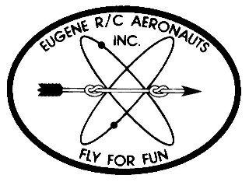
Eugene R/C Aeronauts
PO Box 50034
Eugene, OR. 97405

DEC 2007

Name
Address
City, ST Zip

___________________________Renewing Current Member_____________________________

INVOICE FOR 2008 MEMBERSHIP - EUGENE R/C AERONAUTS

Please fill in the following information and send back with your Dues Remittance

Member Name __________________________________________________________________

2008 AMA Membership No.________________________

I certify that I have paid my 2008 AMA Dues. Initial _________

Member Address _______________________________________________________________

Member Phone No. __________________________

Member Email Address __________________________________________________________

Newsletter Preference: ____ Email ____ Regular Mail ____ Do not need to receive newsletter

Please enclose your check for $ 60.00 as a current member renewing for 2008 and

Mail to: Eugene R/C Aeronauts, PO Box 50034, Eugene, Or. 97405.

Or bring this INVOICE and $60.00 to the January Meeting.

