EUGENE RC AERONAUTS .
Volume 4, Issue 1 www.eugenerc.com January 2008 .
Club Mailing Address: Eugene R/C Aeronauts, PO Box 50034, Eugene, OR. 97405

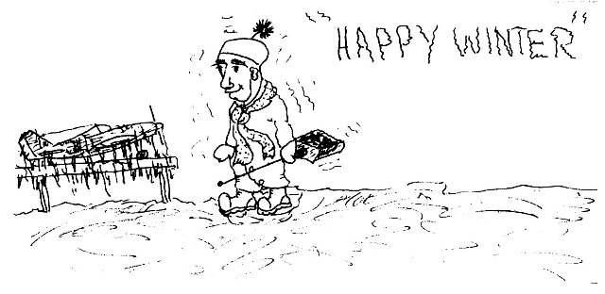dd

CLUB Meeting – January 22, 7:00 pm at EWEB. Bring your dues if you have not already paid them. If you have a winter building project, bring it with you.

DUES TIME – 2008 is HERE, PLEASE pay your AMA and ERCA dues! You will get this Newsletter for a couple months, then if you are not a current member it will stop arriving.

CARL HENSON FIELD – It is still a bit wet, but holding up well. The new mat under the pit tables is keeping the mud off our shoes.

Attention All Pilots:
WINTER FLYING RULES
During November, December,
January, February
Saturday, Sunday & Wednesday
NO FLYING before 12:00 Noon.

BIG BIRD FLY-IN – March 1st, 2008. ERCA will extend an open invitation for the South Lane club to attend the Big Bird Fly-In.

PIZZA MEETING – Club approved having the March 2008 meeting at Papa’s Pizza on Coburg Road.

NEWSLETTER NEEDS INPUT – As your new newsletter editor, I will be relying on INPUT from the Officers and Members.

I would like members to send me photos and a short write-up on any projects they are working on, or new aircraft. If you can’t email it to me, mail me a photo and a note.

Also if you have any building TIPS or TRICKS you would like to share, I would be glad to pass those along.

PLEASE
IF you have an EMAIL account,
PLEASE request your Newsletter via EMAIL.

STAMPS and PAPER
cost the Club (YOU) money.

WHATS NEW

Whats New at: http://www.eugenerc.com/

New "Khoi's Corner" page up and coming!
For more info, click here: http://www.eugenerc.com/khoi.php

This idea is still in the workshop but I think it will greatly help many of our members. Stay tuned!

Kevink@eugenerc.com

FOR SALE

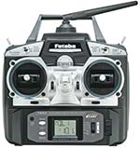
Futaba 6EX Radio set with the 2.4GHz FASST system,
R607FS 6-ch Receiver and four S3004 Ball Bearing Servos.
Full Range System-Ideal For All Types of R/C Aircraft Including Park Flyers. Six model memory

Futaba 6EX radio set - New in Box - $170.
Call Allen Peacock 221-1482

Gripes & Grumbles

Winter WOES
Not raining - with a 25 mph wind.
No wind, No rain, 50 foot visibility.

KUDOS

DougD - Thanks for the original cartoons!

WITH THE WEEKDAY WARRIORS - January 2008

So far, from the 1st of Dec. until now, 1/13, I have been up to the field five times and have been all by myself for three of them - and with good reason. The showers, wind, and cool temperature, individually and in combination, have not made for good flying weather. Chuck Jenkins said he had been alone three out of four times and Jim Corbett, perhaps the smartest of us all, said he hadn’t even made the trip more than once. 1/13 found about ten of us up at the field on a rather calm, sunny, 460 day. Alas, 1/13 was a Sunday and thus unqualified for mention here.

The one weekday when I did find the strip in use was quite early in December. Ken Springate, who has by now joined the legion of drizzlebirds down in the drier climes, was flying his C.A.P. 232. This has non-standard (I think), and rather long, landing gear legs. These tripped him up on one landing and were obviously pulled out of position when the plane was picked up. The bolts hadn’t broken and the plywood plate hadn’t torn out, but that plate had buckled. There were two cracks running from side to side and the plate had bent up between them. The wood looked thick enough for the job, but it appeared that the manufacturer had used a distinctly cheesy grade of the stuff.

The only other flier present was Pat Willis who had what looked to my untutored eye like the best Spread Spectrum I had seen yet. In the transmitting department was the faithful Futaba he’s been using for a while. Well, mostly it was the faithful Futaba. The usual RE’ module had been replaced by a 2.4ghz item from Xtreme R/C. The receiver, from the same outfit, was a wee little thing, only just big enough to plug in all the servos. (NB: Only one receiver) The antenna - only one of them - was a tiny excrescence, hardly an inch tall. In case you are a devotee of large battery packs, this receiver will handle up to 30 volts. Now a 5-cell ni-cad pack, used by people who yearn for more speed from their servos, puts out six volts. 30? That would make the servos supersonic, assuming, of course, that they could take it at all. (Very doubtful) Pat had no idea what situation would require 30 volts through the receiver, but, no doubt, it is some sort of comfort to know the potential is there. He tried the rig first in his monstrous Yak 54 and all was well, then he put it into his new T-Rex 600 Nitro helicopter. Yes, T-Rex now has large glow-powered machines as well as the smaller electrics. In the T-Rex, the minuscule receiver was buried amid battery packs, servo wires, and carbon-fibre sideframes and it carried on receiving. This looks like a system you could put into a Scale ship without disturbing the interior detail. By the way, to range-check this radio, you walk out to 50’. Then you continue around in a full 360⁰ arc, checking every so often around the perimeter.

I have to be careful of how I describe engines. Back in 1950, once the glow plug had sent the spark-ignition engines to the old-folks home, I went on calling any model with an internal combustion engine a “gas job”. Now that gasoline-fired engines are making such a big comeback, such a cavalier approach can lead to misunderstandings. Once this Summer I told a someone on our field that I had been flying a “gas model” earlier. He looked a bit disturbed and concerned, probably imagining a monster with a DA 70 up front roaring into the air with no guidance beyond faith in my trim adjustments. The model in question had been a Fubar 36 with a 54-yr-old Wen-Mac .049 up front. Maybe I’d better start saying “glow”.
One of the things I asked for for Christmas was that nobody bring any J-3 Cubs, particularly yellow ones, to the field for the whole year. Yellow Cubs are an even bigger bore than the plethora of P-51Ds we’ve been plagued with. If you must build a Cub, put a full cowl on it and call it a PA-11. Put flaps on it as well as the full cowl and it’s a PA-18, the Super Cub. And it’s a warbird. The Army called them L-21Bs and some were even in bright yellow as trainers. Better yet, build an Aeronca 7AC, the Champ, which was an L-16 to the military. Of course, that was a 7EC, with the dorsal fin. Stinson Model 10, Voyager, or L-5 - all of them constant-chord, flat-engined, fabric-covered birds. If you don’t mind radial engines, tapered wings, and round fuselages, there are the Cessnas and Luscombes. but, anyhow, no more Cubs for a while - maybe a decade or two.

Chances of this column appearing next month are nil. I will be away for three weeks, returning just in time for the February meeting. I may, however, supply Editor Corbett with something else. I’ve done a couple of things on planes which flopped in the real world, but which modelers took to their hearts. The two I have covered were the Rearwin Speedster and the Fokker D.VIII and I have a couple more in mind. If I get time and if the typewriter cooperates (it’s starting to act up again), I’ll ship an article off to Jim before I go.

C. O’D

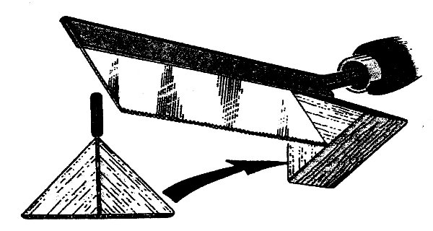

TIPS & TECHNIQUES

Soft Shoe Shuffle
Use CA to glue 90-degree balsa blocks and a very thin ply shoe, with all its edges rounded off, to the end of your hobby-saw blade, making absolutely sure that it is at a right angle to the shoe. This supports the saw at a 90-degree angel while you cut fuselage spacers, ect, and seems to work better than the slotted miter box.
Eric Marsden, Horndean,
Hampshire, England.

Club Contacts:

President – Pat Willis – 543-8999 - p-willis@msn.com
Vice President - Mel Thompson - 746-5699 - met324@comcast.net
Sec/Treasurer – Al Barrington - 935-4960 - albarrington@msn.com
Groundskeeper – Doug McWha - 741-3326 – flyd@clipper.net
Field Marshal - John Bowhan - 607-5752 - jbowhan@epud.net
Frank Blain, Jim Corbett, Bill Hollingsworth, Khoi Tran, Alan Wellentin
Newsletter Editor - Jim Corbett - 344-5022 - james.corbett@comcast.net

Looking at 2008

ONLY THE BOOTED BRAVE TREAD HERE

January 5, 2008

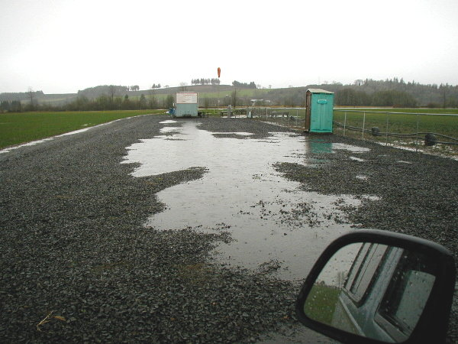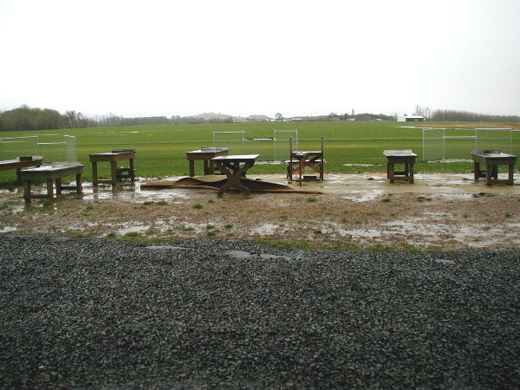

Parking lot Pit area

January 13, 2008

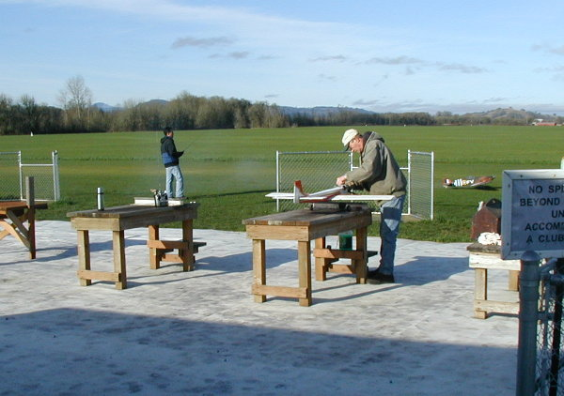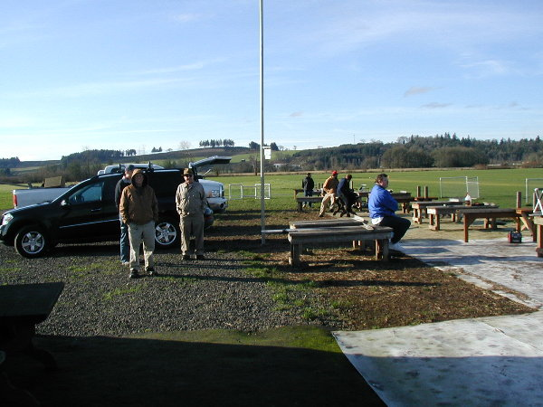

Some Flying Some watching

This can be viewed ONLINE at http://erca.home.comcast.net/~erca/NL/ERCA_NL_Jan08.pdf

--- That’s All Folks ---

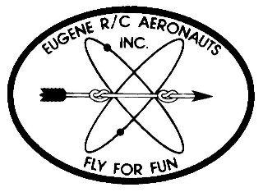
Eugene R/C Aeronauts
PO Box 50034
Eugene, OR. 97405

JAN 2008

Name
Address
City, ST Zip

___________________________Renewing Current Member_____________________________

INVOICE FOR 2008 MEMBERSHIP - EUGENE R/C AERONAUTS

Please fill in the following information and send back with your Dues Remittance

Member Name __________________________________________________________________

2008 AMA Membership No.________________________

I certify that I have paid my 2008 AMA Dues. Initial _________

Member Address _______________________________________________________________

Member Phone No. __________________________

Member Email Address __________________________________________________________

Newsletter Preference: ____ Email ____ Regular Mail ____ Do not need to receive newsletter

Please enclose your check for $ 60.00 as a current member renewing for 2008 and

Mail to: Eugene R/C Aeronauts, PO Box 50034, Eugene, Or. 97405.

Or bring this INVOICE and $60.00 to the January Meeting.

