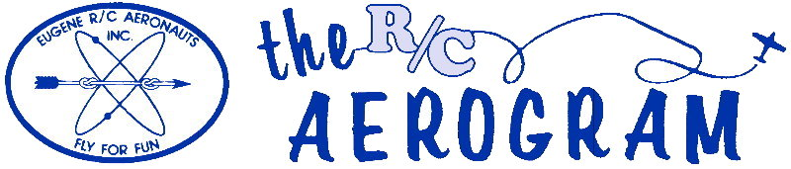

Volume 4 Issue 7 AMA #530 District 11 www.eugenerc.com July 2008

Club Mailing Address: Eugene R/C Aeronauts, PO Box 26344, Eugene, OR. 97402

ERCA News and Information

Next CLUB Meeting – July 22, 7:00 pm at the field. If you have a building project, bring it with you for "Show and Tell".

At the June Meeting – Roughly 30 members and a few guests present. Doug McWha and Chuck did the shopping and Doug McWha and Al did the cooking. There was plenty of flying before and after the meeting.
Our treasurer provided a budget that predicts a yearly operating cost of about $5800.00. The membership pondered raising the yearly dues but nothing was put into motion.
Someone has been leaving their trash in the buckets inside the club house that are used for storage. There is no trash receptacle at the field, take your garbage with you.
Cigarette butts have once again been found on the ground in the parking lot and pit area.
The "No pets" rule was reviewed and it was decided that the rule stands as-is. There is no exception to the rule and that includes animals in vehicles.
Smoking is allowed only in vehicles. It was agreed that smoking while seated on a truck's tailgate is considered the same as being inside the vehicle.
Some planes have been spotted over and beyond the Burgess home. There is no flying over the Burgess house. The obvious safety concerns were discussed.
A non-AMA member came out to fly saying that he had permission from another member. The club reviewed the rules regarding the AMA Intro Pilot program, which requires a non-AMA member to only fly with the club's official/designated Intro pilots, (have to be registered through AMA). They also have to be on a buddy box to be in compliance. They can only be taught by the Intro pilot for 60 days, starting on the day of the first flight, and then they have to join AMA.
Any AMA member, however, can teach any other current AMA member how to fly via buddy box or without. The club does not have any discretion in this matter, it's the rules.
Carl Henson's family stopped by to let us know that Carl's health has taken a turn for the worse and he will likely never be able to come out to his flying field again
FUN Fly – Our annual FUN Fly has been scheduled for August 16th and 17th, 2008
Carl Henson Field – The field is in GREAT condition.
Newsletter Input – So far this year there has been a fair amount of input, keep it coming PLEASE!

Meeting minutes are ONLINE at: http://erca.home.comcast.net/%7Eerca/Meetings.html

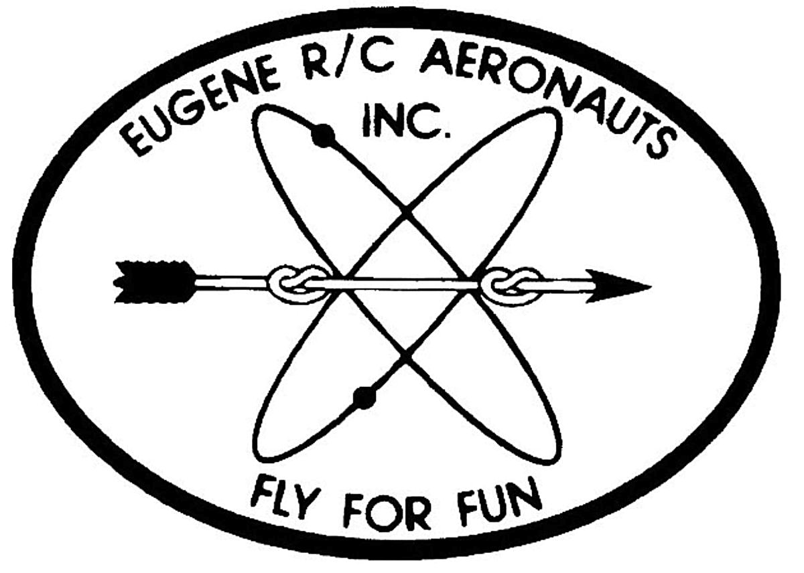
Eugene R/C Aeronauts
Newsletter Editor
1618 Gilham Rd.
Eugene, OR. 97401

JULY 2008

Name

Address
City, ST Zip

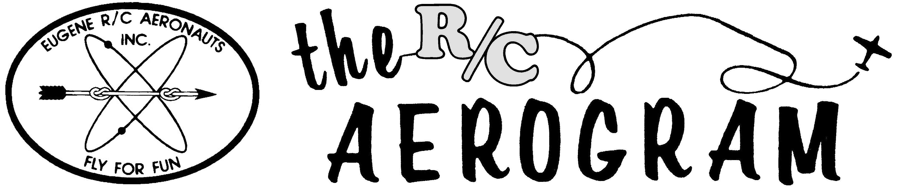

ERCA CLUB CONTACTS

President: Pat Willis – 543-8999 - p-willis@msn.com
Vice President: Mel Thompson - 746-5699 - met324@comcast.net
Sec/Treasurer: Al Barrington - 935-4960 - albarrington@msn.com
Groundskeeper: Doug McWha - 741-3326 – flyduke@comcast.net
Field Marshals: John Bowhan - 607-5752 - jbowhan@epud.net
Frank Blain, Jim Corbett, Bill Hollingsworth, Khoi Tran, Alan Wellentin
Newsletter Editor: Jim Corbett - 344-5022 - james.corbett@comcast.net

Newsletter ONLINE at: http://erca.home.comcast.net/%7Eerca/NL/ CURRENTNEWSLETTER.pdf

