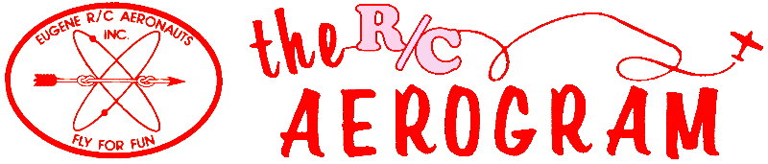

Volume 4 Issue 6 AMA #530 District 11 www.eugenerc.com June 2008

Club Mailing Address: Eugene R/C Aeronauts, PO Box 26344, Eugene, OR. 97402

ERCA News and Information

Next CLUB Meeting – June 24, 7:00 pm at the field. If you have a building project, bring it with you for "Show and Tell".

At the May Meeting – There were 24 members and guests at the meeting.
Our annual FUN Fly has been scheduled for August 16th and 17th, 2008.
Khoi and Frank are still planning to provide a report on options for providing 12v and 110 ac converted power at the Alvadore field.
A reminder that we are moving into the summer meeting months. June we will be at the field.
Rules clarification: any AMA member may assist another AMA member with flight instruction (buddy box etc.) but all non AMA members must only be instructed by an AMA Intro Pilot.
Two new members, Wayne Wahrmund and Aaron bailey, were welcomed into the club.

There was a discussion regarding the belief that too many club members were being comp’d their membership dues. A motion was made and passed by majority vote limiting free membership for club officers to the positions of president and secretary/treasurer. This will take effect for membership year 2009.
Several members reported finding cigarette butts in the pits and parking lot at the field. An informal discussion lead to a suggestion we place a larger sign near the entrance to the fields warning of the fire danger and smoking rules.
Show&Tell – Frank brought his new Great Planes SU-31 for show.
The BigBird Fly – was held on Saturday, June 14th. Twenty plus members showed up for a windy day. Fewer than half braved the breezy conditions. Food and conversation ruled the day.
Carl Henson Field – The field was fertilized the last week in May and has been watered at least once each week since, if the sun starts showing up more often, the mowing and watering will need to be more frequent.
Some more mat scraps have been nailed down. A DRY access path from the west parking area to the pit area.
Another “NO PARKING” loading and unloading area on the East end of the club house has been marked. This gives two places for flyers to unload and load very close to the pit area.
Newsletter Input – So far this year there has been a fair amount of input, keep it coming PLEASE!

Meeting minutes are ONLINE at: http://erca.home.comcast.net/%7Eerca/Meetings.html

SHOW & TELL

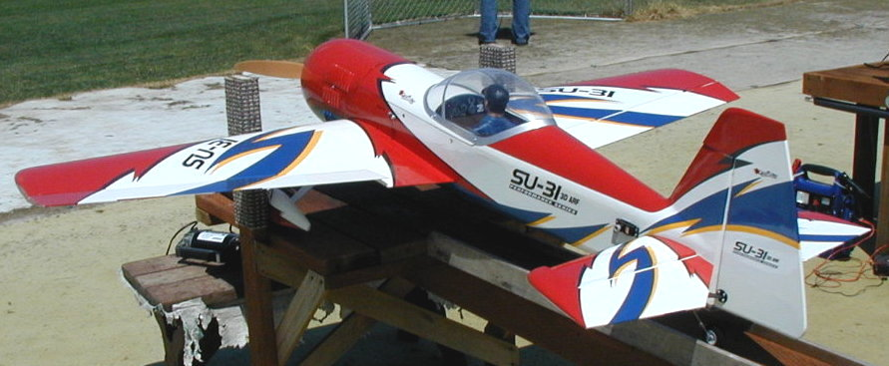
Goldberg SU-31

Wing span: 88"
Weight: 14 lbs
Engine: DL-50
Prop: 22/8

Franks Comment: AMAZING!

Treasurers Corner

2008 Mar 87 members are confirmed current with AMA and ERCA.
3 new members joined this month.
Thanks to everyone for their prompt renewals.
2008 Apr 92 members are confirmed.
1 new member has joined.
2008 May 95 members are confirmed.
2 new members have joined.

Our PO Box has changed to: P.O. Box 26344, Eugene, Or 97402.

Any OFFICAL ERCA mailings should be sent to this mailing address.

KUDOS

Doug and Chuck - Big Bird Cooks. Doug, Frank, Mel and Jim - Field Prep for the Big Bird Fly.

Projects

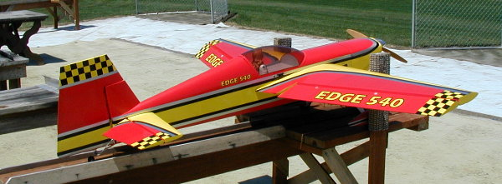
Edge 540

Wing span:
Engine: Had Moki 180,
Now Fugi 43
Prop: 20/10

Franks Comment: Servos were
twitching, replaced the switch
harness, all is well now.

WITH THE WEEKDAY WARRIORS - June 2008

When I started flying with this club back in ‘92, I had to make an adjustment. The clubs I had flown with back home and in Illinois were made up of afternoon and evening fliers. Here, if I showed up after 1:00, I was meeting the last of the crowd as it left. Now, it seems, people are coming out to our field later and later. I’ve been out at the strip around 10:00 on a nice day and found myself alone. I’d give up, leave around noon, and meet people several miles down the road who were headed for the field. Are we becoming an afternoon club?
And we are beginning to get nice days, even strings of three or four in a row! You knew that Vern Wells’s EasySport met a sad end last month when it shed its wing in the air. Vern has replaced it with a Hangar 9 Super Stik in which he has a Magnum .46 for power. The Super Stik looks to me like a modern incarnation of the old Midwest Sweet Stik, the 40-size version of the classic Das Ugly Stik. Maybe very slightly larger? Twenty years ago, I had a Sweet Stik with an 0.S. .4OFSR up front and it was a very nice sport ship. Chuck Jenkins test-flew and trimmed Vern’s new plane, then turned it over to Vein. He got in a couple of flights before over-banking and losing a lot of altitude close to the ground. He managed to level out, but not pull up before the air underneath him turned into grass. I’m not sure whether the praise goes to the toughness of Hangar 9’s construction or the forgiving qualities of our grass, but the engine, mount, and firewall came out cleanly, leaving the rest of the model intact.
Scott Kenyon brought out a vast Extra 320S. It has a Desert Aircraft DA 100 for power, so you know it’s not a delicate little chickadee. Frank Blain is another guy who shows us some very large machines on these midweek days. You heard last month that he re-engined his big Yak 54 with a DL 50. (“What, only a 50?”, you say.) Well, now he has taken the Fuji 43 that had been in his Extra and put it into his Edge 540, replacing a Moki 1.80. I don’t know where the Moki has gone. In fact, I’m not at all sure that I have all those engine/aeroplane swaps straight. Frank has so many engines and planes! With the mention above of Moki, I am moved to reflect that they have been around a long time. Back when the Iron Curtain was firmly in place, Moki were the state-run company that supplied engines to the Hungarian team for the World Championships in U/C Speed and Team Racing. You couldn’t buy one, but, sometimes, members of the teams were allowed to trade one for something interesting from the West. MVVS was the Czech equivalent.
Wayne Wahrmund is progressing under the tutelage of Chuck Jenkins. He’s making his own takeoffs and, I believe, has essayed a landing or two. A bit shaky in both departments, it’s true, but weren’t we all at that stage? And aren’t we all from time to time even now? One morning Wayne called to the rest of us that we should watch out because he was about to fly. Someone replied, “Why should we watch you?”, and Wayne’s comeback was, “Because I’m funny to watch”.
Jim Corbett, your editor, doesn’t spend all his time up in the palatial suite of offices this newsletter maintains. He has been flying a pair of Lanier Stingers, one electric, the other glow. The larger glow bird settles down to a nice, smooth landing, but the small electric habitually progresses in series of hops. Jim hasn’t solved that one yet. He and Doug McWha spent a good portion of one nice morning attending to the blades on the mowers. That’s the rest of the story

WITH THE WEEKDAY WARRIORS - continued

about keeping the strip in as good a shape as it is. Besides the mowing, there’s the maintenance on the mowers - a few hours for every hour spent moving. Not nearly as bad as military aircraft, but something you have to consider.
Anybody got an empty kit box? At least 3’ long, 8” or 9” wide, and 4” deep. I have all my strip wood, wire, tubing, plastic strip, motor-mount wood, and the like in two boxes and I’d like to categorize it a little better. You know, keep the 1/16 sq. and 1/16x1/8 out of the same box with the ½” sq and the same for the fine wire and tubing.
I doubt that this column will appear next month - you get a break. During the time when I should be gathering material, I’ll be 5,000-odd miles away and I won’t be back until the night before the meeting. Weather permitting, I’ll see two air shows at Old Warden, one on the first Sunday and the other on Saturday evening two weeks later. The June and August shows are each labeled “Military Air Pageant”, but the July show is simply “Summer Air Display”, so I hope to see a lot of the good, old civil machines. Nothing against the military birds, but there are a ton of beautiful civil ships, many of them eminently modelable. You don’t have to be military to go fast. The Chilton DW.1 had the modest 32 h.p. of a 4-cylinder British Ford auto engine, complete with radiator, but it cruised at 100 mph. Only four DW.ls were built before WWII interfered. As they were single-seaters, the RAF wasn’t interested in impressing them, so they were dismantled and stored. Remarkably, all survive today. Two are airworthy and the other two are under restoration. That’s the sort of thing I hope to see. On the weekend in the middle, there’s an airshow at Duxford. That will be mostly WWII stuff and they always have some exotic birds flown in from foreign countries. Further, there is a good chance of seeing two Gladiators (the RAF’s last biplane fighter) in the air together. Wonder how many Spitfires/ Seafires they’ll be able to muster? I’ll bring back pictures.

C.O'D.

Projects

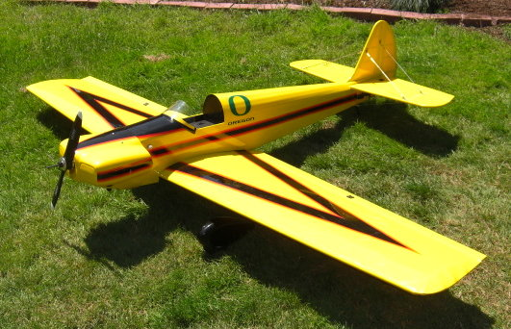

Bizzy Bee

Marty’s has been building a Bizzy Bee for a friend in LaPine!

Presidents Corner

The flying season is officially here! Unfortunately, so are allergies, so go get your shots, take your meds, and meet me at the flying field...
I recall an incident when I was flying through somewhat blurry vision as the wind in my face brought an unknown type of allergen across my eyeballs, causing my eyes to water and my eyelids to involuntarily close, (known in the medical field as blepharospasms). Then, to add some insult to the injury, a hornet flew up my shorts and stung me on the upper leg, (hey, it could have been worse!!). This was one of the times that Bill H. and I were flying combat. I'm thankful he didn't call me "chicken" when I landed with the streamer on my airplane still intact.
I went out this past Monday, (6/16) and with the sun on my face and only a light breeze, the handful of us that braved the UV rays took to the skies and had a great time. I've been practicing harrier landings with my Yak and my Giles. This is definitely a crowd pleaser, I'm finding, since it looks like I may crash anytime. I've been lucky so far, but don't look away or you might miss something quite spectacular. So far, only my tailgear has been damaged.
The runway is looking more and more like a golf course. My thanks to Doug, Jim, and the handful of others that are putting out the time and energy to make it great for all of us.
I must offer my sincere apologies to you folks for not being at the last meeting. My son came down with a stomach bug a few hours before the meeting, and even though he said I could go, I just couldn't leave him. My thanks to Mel for taking my place. You may have also noticed I didn't make it to the Big Bird Fly-in. That one was not my fault. I normally work on Saturdays, but I did ask for the day off in advance. Unfortunately, because of low staffing levels, I was denied the time off. I have also been denied the time off for day one of the annual Fun-Fly, but I will be out on day two for sure.
The next meeting will be held out at the flying field, so show up early, bring a plane, (or chopper!) and join your fellow club members for some flying before the meeting. Until then remember, you can only tie the record for the lowest fly-by...

Patrick Willis
ERCA President 2007-2008

--- That's All Folks ---

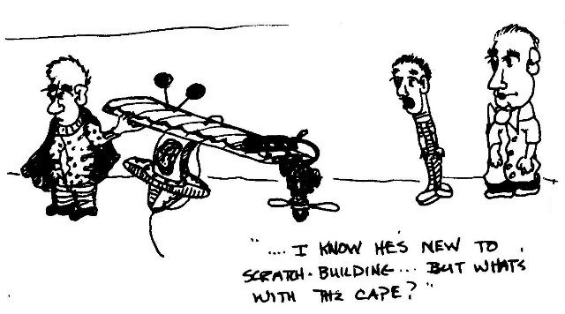

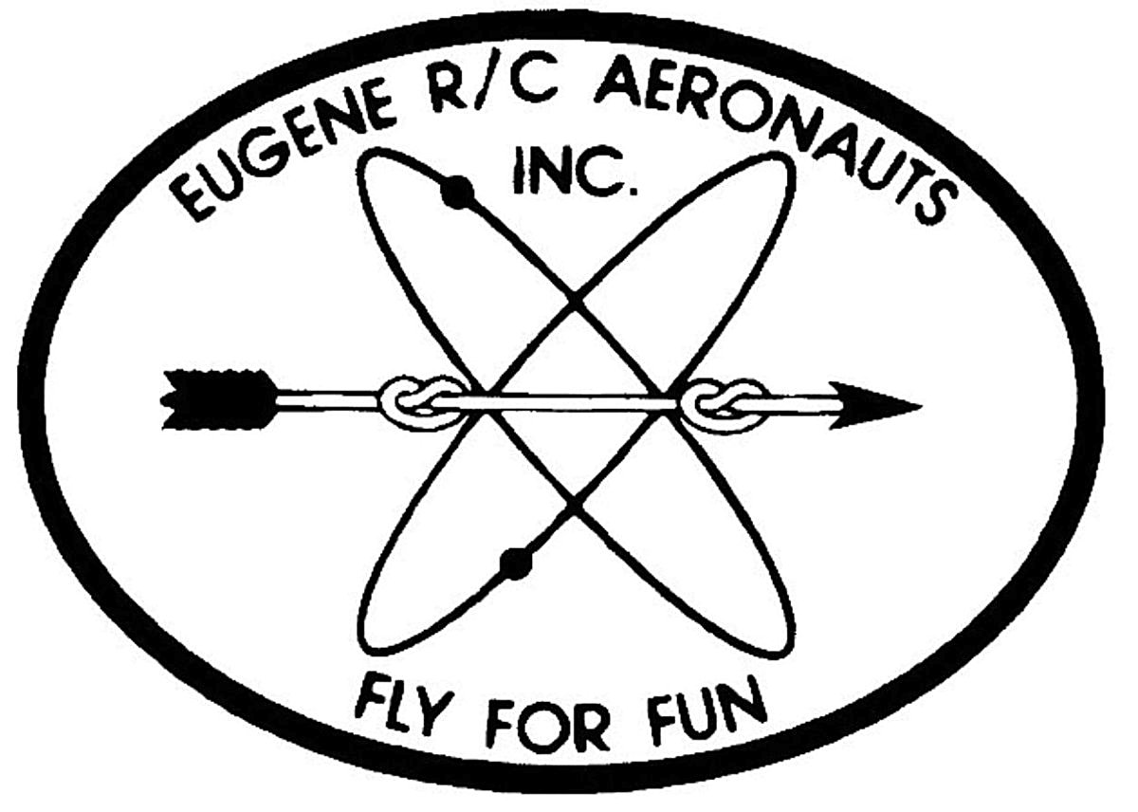
Eugene R/C Aeronauts
Newsletter Editor
1618 Gilham Rd.
Eugene, OR. 97401

JUNE 2008

Name

Address
City, ST Zip

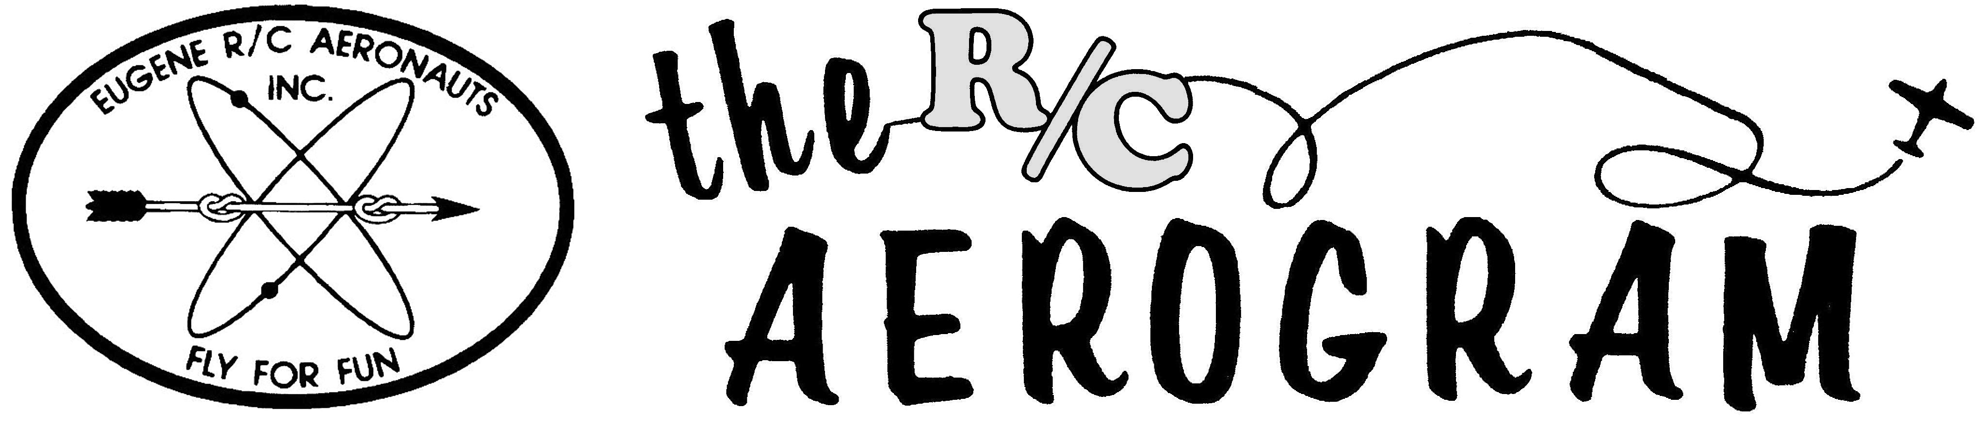

ERCA CLUB CONTACTS

President: Pat Willis – 543-8999 - p-willis@msn.com
Vice President: Mel Thompson - 746-5699 - met324@comcast.net
Sec/Treasurer: Al Barrington - 935-4960 - albarrington@msn.com
Groundskeeper: Doug McWha - 741-3326 – flyduke@comcast.net
Field Marshals: John Bowhan - 607-5752 - jbowhan@epud.net
Frank Blain, Jim Corbett, Bill Hollingsworth, Khoi Tran, Alan Wellentin
Newsletter Editor: Jim Corbett - 344-5022 - james.corbett@comcast.net

Newsletter ONLINE at: http://erca.home.comcast.net/%7Eerca/NL/ CURRENTNEWSLETTER.pdf

