EUGENE R/C AERONAUTS .
Volume 4, Issue 3 AMA #530 District 11 www.eugenerc.com March 2008 .
.
Club Mailing Address: Eugene R/C Aeronauts, PO Box 50034, Eugene, OR. 97405

News and Information

Next CLUB Meeting – March 25, 7:00 pm at Papa’s Pizza on Coburg Road. Bring your dues if you have not already paid them. If you have a winter building project, bring it with you.
At the February Meeting – We had another installment of Khoi’s Corner LIVE! This month’s presentation covered part two of his two part series on retractable landing gear.
This month we got to see the scale applications available. Khoi shared his insight into the customer service philosophy of the better suppliers for this equipment.
We had show and tell from the Bowhans’ with their small herd of Axe CP heli’s and Erin showed off a new Futaba 7C 2.4gHz radio.
Allen Peacock announced he is going to give fixed wing a shot and presented his all ‘styro’ electric super cub that he intends on using. Allen proposed the establishment of a charter Piper Cub Owners Association (PCOS) within ERCA. He modeled hats, t-shirts and mugs he has designed for those that love, like or merely tolerate one of the greatest machines to ever take flight ;-)
29 members attended the February meeting. Two new members applied and were voted into the club. Please welcome Don Desimone and Brian Ropchan.

DUES TIME – PLEASE pay your 2008 AMA and ERCA dues! A reminder to all that membership renewals are due by the close of the March meeting.

Without prior arrangements, expired members will be dropped from club roster after that deadline! Renewing members are expected to pay their dues in full while new members may pay in thirds if necessary.
CARL HENSON FIELD – It is still a bit wet. The field was mowed a couple times in February and fertilizer was applied and the field was mowed a couple times during March. On March 4th a work crew installed some more of the brown matting under the pit tables. Also some of the White mat was laid over the electric runway, it is now longer and wider. Discussion of the areas we can NOT FLY OVER has come up again, I expect that there will be a drawing on the club house bulletin board soon.
The Big Bird Fly In" was "weathered out". Several people showed up ready to fly but the weather did not co-operate.
Sutherlin-Plat I Float Fly - join the Umpqua Valley Modelers at the. The event runs 4 days, June 19-22. It is AMA sanctioned and will have a recovery boat the entire event. The pilots fee is $10.00 for the event. $5.00 spaghetti feed on Thursday night.

Attention All Pilots:
WINTER FLYING RULES
ARE OVER
as of March 1st

You now can FLY before 12:00 Noon.

NEWSLETTER NEEDS INPUT – If you have any building TIPS or TRICKS you would like to share, I would be glad to pass those along.

WHATS NEW

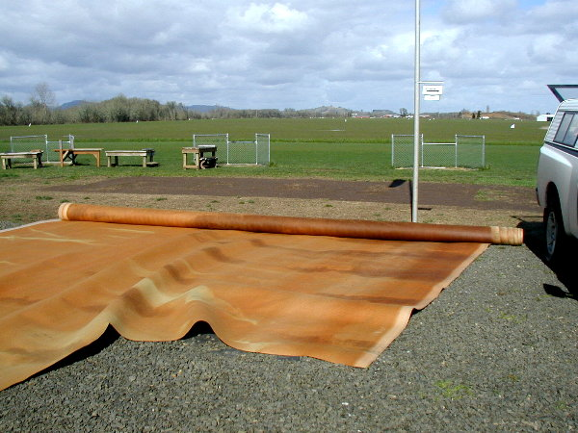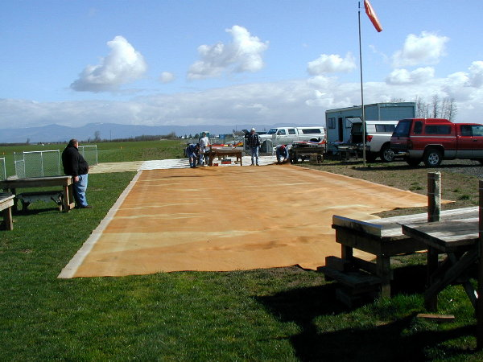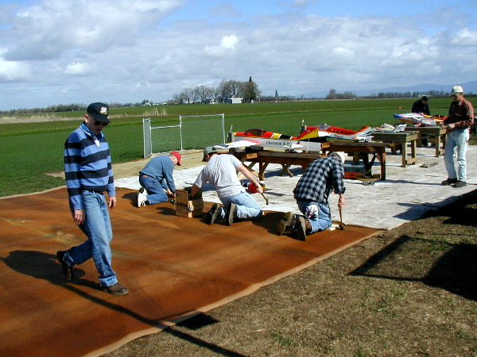
Pit area mat extended.
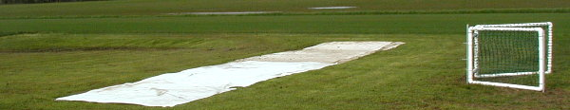
Electric Runway covered with light mat material, a pit wider and a bit longer than before.
ALSO
Freq Pins – some were a bit dilapidated, most have been replaced. They were printed on “All Weather” paper, we will have to wait and see how long they hold up.

FOR SALE - WANTED

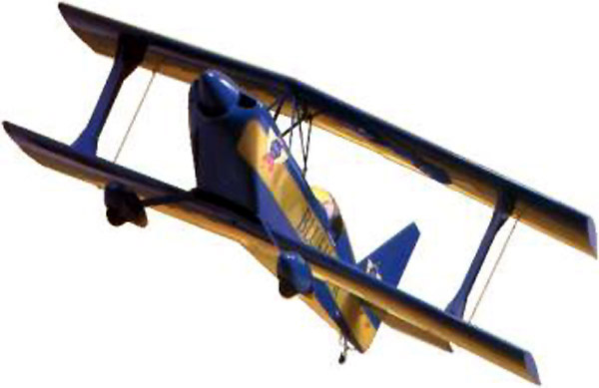
Carl Goldberg Ultimate 10-300 biplane kit (not ARF) $100.00
Contact: mikedenlis@kendallauto.com
Statistics:
Wingspan: 54"
Wing Area: 980 Sq."
Flying Weight: 8 lbs.
Fuse Length: 57.5"
Radio: 4-Channel
Power: .
• .60-.90 2-Cycle
• .80-1.20 4-Cycle
Street price $169 - $199
More Info:
www.carlgoldbergproducts.com/airplanes/gbga1053.html
http://webpages.charter.net/rcfu/KitReviews/CGUlt.html

KUDOS

.A big thanks to the mat party crew -- Doug, Mel, Larry, Al, Frank, Pat, Jim and Chuck.

TIPS & TECHNIQUES

Safety Tips From Bill Hollingsworth: Field/Safety Marshall

I know it sounds like common sense, but you should NEVER reach over your prop to remove a glow-bee (or ni-start) from your engine while it is running! ALWAYS walk behind the engine and remove the glow-bee from BEHIND the prop! Also, when starting your engine, make sure that other members or spectators are BEHIND the prop and spinner! Although rare, we have all seen bloody fingers and prop/spinner failures.

Presidents Corner

The flying season, (for those of you that don't fly all year long) is right around the corner. We spent some time this month installing some new mats down in the pit area to keep the mud under control. My thanks to Doug McWha for helping us to obtain the mats and to the handful of members that showed up to help nail it down. The runway is still looking fantastic and, thanks to the well and sprinkler system and all of Doug's hard work, it may never be brown again...

Which leads me once again to recommend that you try to make it to the work parties that happen a few times a year. I know that the word "party" is used loosely in that scenario, because there's not much booze, dancing, or women, but on the plus side, you don't get hungover afterward and your club benefits greatly from it. If you can't make it to the work parties, consider offering to help Doug mow the lawn. It doesn't take long, and he really appreciates the help.

Jim Corbett is going to make some more 2.4 GHz frequency pins and plans to replace the other frequency pins on the board. For those of you on 2.4 GHz, you are still required to go grab a pin and put your AMA card or your club member card in the slot.
The club has six Safety Officers now. If one of them happens to bring up a rule that you may have broken, please treat them with respect. They are trying to keep you and everyone else safe and in compliance with the rules that the membership has approved. Some of the more common violations are flying over the pits or in another no-fly area, smoking in the pits area or outside a vehicle during the fire season, not putting your AMA or club card in the frequency board, and flying without AMA membership. I know that sometimes folks may find themselves wanting to bring a friend out to try out R/C aircraft. Keep in mind that, unless you're an intro. pilot, you cannot let them fly, even on a buddy box or with you standing there assisting. Remember that the club recently voted at a meeting to suspend people from being able to fly at our facility if they fly without AMA. That may apply to the member in the preceding scenario, so please just find an intro. pilot or consider becoming one yourself! Talk to Al Barrington if you want to become an intro. pilot.
I have finished my revisions of the club By-Laws and Constitution. I made the revisions based on what the club has previously voted on and I'll be bringing a few copies to the next meeting. They will then be put in for approval at the following meeting assuming there are no issues raised or revisions needed.
The Big Bird Fly-in was cancelled due to wet weather from what I'm told. I had to work that day, unfortunately, but my thanks to the VP for handling the event.
I'm off to get some time on the sim. For those of you that have seen me fly a helicopter, you already know that I need the practice...

Happy Landings...
Patrick Willis
ERCA President

Treasurers Corner

2008 Jan 34 members have paid their dues, 1 new member has joined.

2008 Feb 58 members confirmed current with AMA and ERCA.
2 new members have joined this month.

Thanks to everyone for their prompt renewals. 2008 Membership cards have been mailed and should be arriving soon.

We have 47 of our 2007 members on the 2008 Unknown Status list. Please help in contacting them and hopefully retaining them as members.

Meeting minutes are available at: http://erca.home.comcast.net/%7Eerca/Meetings.html

Field Marshals Corner

heli-pad area

The square to the west of the pits has been designated heli and small electric airplanes. I think it's cool to be able to have a runway for small planes and a space for heli hovering.

The problem I have is when an airplane ends up over the area either on take off or landing, (yes, I have seen both instances). I have recently noticed many people over flying this space, in my opinion, that is unacceptable. An aircraft, fixed wing or rotory wing, should NEVER be behind the pilot stations unless, of course, it isn't flying.
I recently have seen a person nearly get hit which prompted them to land their heli and not fly for the rest of the day. We are seeing more and more pilots giving helis a try so the "heli-pad" is seeing more and more people both using it and watching.

Alan

WITH THE WEEKDAY WARRIORS - March 2008

Off I went to Australia with the idea of getting out of the dreary Oregon weather and into the Australian Summer sunshine. Returning seventeen days later, I found that you had had less rain here than I did there. I carried the umbrella more often than I did the sunglasses for the first 2/3 of the trip. Melbourne, at least, greeted me with 90⁰ and sunshine until the last day, when it rained all day - just like Oregon. The dreary weather returned with me and I haven’t seen much action at the field on weekdays. I did miss some decent days due to appointments with doctors, labs, and auto maintenance, but what follows is what little I did see.
One foggy morning I found Alan Wellintin up there with one of his 90-powered, rotary-winged monsters. He was waiting out the fog which seemed to start to clear, then come back. At long last visibility was good enough for Alan to fly the helicopter in his usual fashion. You know, loops rolls, flying backwards, inverted - the normal helicopter stuff. (Normal for whom? Well, Alan, I suppose.)
Troy Dannenbring is still in the early stages of the helicopter business, so he has no problems with the fog. He’s not yet flying high enough to be concerned about it. If he can look down and still see his shoetops through the fog, the ceiling is high enough. Troy is flying one of those ubiquitous T-Rex 600s as well as one of the smaller electric ships. In fact, he has three of the nitro T-Rexes, all acquired second-hand (we don’t have to say “pre-owned”, do we?). He’s flying the one, another is playing hangar-queen as a source of parts, but it is the third one that piques my interest. It is to have a Hughes 500 body put on it once it is properly set up and trimmed out. I confess to a tendency toward yawning in the presence of helicopters, but a Scale ship (!) is another story. I’ll be looking forward to an R-4, an R-5, one of those Robinsons with the high, streamlined mast, an H-64 lifting the air-conditioner up to the top of the trailer. Troy says that the one non-scale fly-in-the-ointment is the fact that the T-Rex has its tail rotor on the right side of the boom and the Hughes’s is on the left. Actually, that may stand him in good stead if the suits from Hughes try to get royalties out of him for building a model of their machine. “What, a Huges 500? Certainly not!. Look at the tail rotor.” That T-Rex was supposed to have flown that day, but had to be scratched due to a clutch being set up just a bit too tight.
I don’t know what Chuck Jenkins has in mind for the future, but he was up at the field running an engine on a test stand. This was a YS .90 that Chuck has had a full ten years, but has never had in a plane. The last time it was run - on the test stand - was down at Short Mountain, then something occurred that caused it to be put aside until now. Okay, what ideas are simmering on CJ’s back burner? Stay tuned.
Just the other day, Doug McWha was flying his Dual Ace. The twin flew as well as it always does, but the big news concerned Doug’s Lancair. For the details, you will have to consult the guy who writes the weekend column, but the bare bones of the story are these: While dealing with an engine problem, Doug let the Lancair get out too far, lost orientation, and saw it go into the ground on the other side of the brook that borders the west side of the field. Wing in two pieces and the nose looked pretty sad. It is now in the hands of Bill Hastings and may well gain a new life. I’m not sure how many lives are attributed to models. Mike McKevitt had a big, old Cub Coupe or Cruiser - I can’t remember which - that must have exceeded the cat’s proverbial nine. I can remember walking, with Mike and somebody else, down the hill at Short Mountain with a double handful of shockingly small pieces, which Mike then glued back into an aeroplane. He did this so often that he developed a way of peeling off Coverite and ironing it back on when the repairs were finished.
I did manage visits to two air museums while I was in Australia. The Australian National Air Museum at Moorabin Airport is busy on the restorations of their newly-acquired DC-2 and Bristol Beaufort. The Douglas had been parked outside, the subject of an ownership dispute, for nearly ten years before the museum rescued it. I don't know where the Beaufort came from nor whether it’s British- or Australian-built. This museum needs at least two more big hangars.
So does the RAAF Museum at Pt. Cook. They have four rare birds, a Boomerang, a Dragon, an Avro Cadet, and a Hawker Demon jammed into a hanger with a load of other planes. The only view you have of them is from a balcony on one side of the hangar - a balcony with a heavy cyclone fence all around it. They have instituted a flying display on Sundays, Tuesdays, and Thursdays. Just a half-hour or so, but the possible performers include a Tiger Moth, a Pup replica, a P-51 (Australian-built), and a CT-4. The last is a fairly modern (80s) trainer and that, alas, is what was on for my visit. Even duller than a P-51!
I hope this doesn’t alarm you, but I thought you should be forewarned. Your columnist now has a new power panel and fuel pump to replace the ones that went bad after only about 35 years’ use. (I know, I know. I should have bought the good ones in the first place.) What may be even more frightening is that he has a new 12-volt battery that will run them both - and it’s charged. They are about to pull the rug out from under me in Freeflight by abolishing the Builder-of-the-Model Rule. I am a firm believer in the principle that you build the model you compete with, but the “pothunters” with deep pockets want to win more awards and I am afraid they have the votes on the Contest Board. Except for a Scale ship, my FF projects are on “hold” and I’m dreaming up R/C projects.

C. O'D

SWAP & SHOP

Rogue Valley Flyers - Grants Pass Oregon
March 22, 2008
Location - National Guard Armory - 666 Brookside Boulevard
5 miles northwest of Grants Pass at Airport

Details Set up 7:00 a.m.
Doors open at 9:00 a.m. to 3:00 p.m.
Tables $20.00 each - Includes 1 admission
General admission $2.00 at door
For information contact Len Barker
Phone 541-956-9384 or email lenlin@charter.net
See Flyer http://erca.home.comcast.net/%7Eerca/Text/Swap_03-22-08.pdf

TIPS & TECHNIQUES

small NUTS From Chuck Jenkins - Intro pilot

When trying to install very small nuts on screws that's hard to get to: Put the nut on the screw and push it inside a piece of fuel line, then unscrew, and you have a nut holder. Works great, try it.

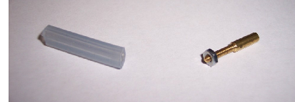
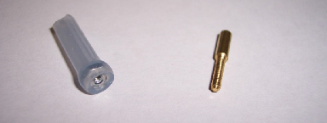

Club Contacts

President: Pat Willis – 543-8999 - p-willis@msn.com
Vice President: Mel Thompson - 746-5699 - met324@comcast.net
Sec/Treasurer: Al Barrington - 935-4960 - albarrington@msn.com
Groundskeeper: Doug McWha - 741-3326 – flyd@clipper.net
Field Marshals: John Bowhan - 607-5752 - jbowhan@epud.net
Frank Blain, Jim Corbett, Bill Hollingsworth, Khoi Tran, Alan Wellentin
Newsletter Editor: Jim Corbett - 344-5022 - james.corbett@comcast.net

FOR SALE - WANTED

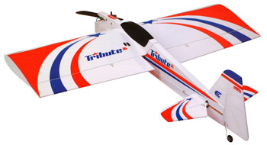
Hanger 9 Tribute with a Magnum 46
Low time and lots of power for 3D, 5 Futaba servos, Hobbico Voltwatch 2 ,HD switch/charge jack, the plane has been recovered in red metallic Monokote with pearl white stripes. This thing is a 3D Monster!!!
I can test fly this plane if you want to see it fly out at the field just call me @ 541 999 7612 ask for Nick.
(Similar to picture) Asking price - $150 (or offer). Nick Speer

Specs
* Wing Span:44 5/8" (1133.4mm) * Overall Length:48" (1219.2mm)
* Wing Area:690 sq. in. (44.5 sq dm) * Flying Weight:4–4.5 Lbs (1.8–2 kg)
* Engine Size:.32–.36 2-stroke, .40–.52
4-stroke (some 4-strokes require mount mod) * Radio:4 channel w/ 5 servos

This can be viewed ONLINE at http://erca.home.comcast.net/%7Eerca/NL/ERCA_NL_Mar08.pdf

--- That’s All Folks ---

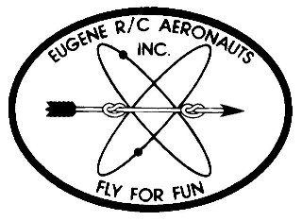
Eugene R/C Aeronauts
Newsletter Editor
1618 Gilham Rd.
Eugene, OR. 97401

MAR 2008

Name
Address
City, ST Zip

___________________________Renewing Current Member_____________________________

INVOICE FOR 2008 MEMBERSHIP - EUGENE R/C AERONAUTS

Please fill in the following information and send back with your Dues Remittance

Member Name __________________________________________________________________

2008 AMA Membership No.________________________

I certify that I have paid my 2008 AMA Dues. Initial _________

Member Address _______________________________________________________________

Member Phone No. __________________________

Member Email Address __________________________________________________________

Newsletter Preference: ____ Email ____ Regular Mail ____ Do not need to receive newsletter

Please enclose your check for $ 60.00 as a current member renewing for 2008 and

Mail to: Eugene R/C Aeronauts, PO Box 50034, Eugene, Or. 97405.

Or bring this INVOICE and $60.00 to the March Meeting.

