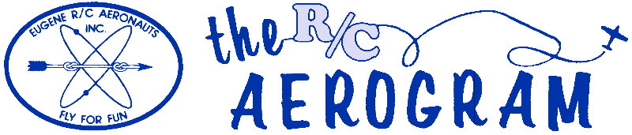

Volume 4 Issue 11 Pages 10 AMA #530 District 11 www.eugenerc.com November 2008

Club Mailing Address: Eugene R/C Aeronauts, PO Box 26344, Eugene, OR. 97402

ERCA News and Information

Next CLUB Meeting – November 25, 7:00 pm at EWEB. If you have a building project, bring it with you for "Show and Tell".
At the October Meeting – There were 15 members and guests at the meeting.
Al Barrington reported we have 105 members in good standing as of the end of October.
A friendly and timely reminder from our Treasurer Al, "It’s quickly approaching dues renewal time!"
The X wind runway that has been pre-empted by those farming the adjacent land was discussed again regarding the benefits of “only” filling in the low area south of the current runway, west of the clubhouse.
Doug and crew are still waiting for the weather to sink some pipe at ground level to be used for run-up anchors for extreme scale planes.
Jeff Engel advised he has a riding lawnmower for sale, offered to the club for $250.
The Port-a-potty service will change to on demand servicing for the winter months.
We raffled off the leftover gift certificates from the Fun Fly by giving each attendee a ticket and then sold additional tickets for the usual; one for $1 and 6 for $5.
Don Desimone, Steve Harris and Jeff Engel each won a $10 Eugene Toy and Hobby gift certificate. The sale of additional raffle tickets produced $16 in revenue for the club.
The November meeting will bring us board elections for 2009.
Nominations were completed as follows:

President: Khoi Tran
Vice President: Mel Thompson
Sec/Treasurer: Al Barrington
Safety Officers: Troy Dankenbring,
Marty Wittman,
Bill Hollingsworth,
John Bowhan

Winter Flying Hours - During November, December, January, February - Saturday, Sunday & Wednesday flying start time is 12:00 Noon.

Meeting minutes are ONLINE at: http://eugenerc.com/meetings.html

New pages on EugeneRC.com: Projects – Reviews – by ERCA members.

Presidents Corner

This is the last time I'll be writing as your President. Looking back at the last two years, I'm very satisfied with the club's accomplishments. We have 105 members in good standing and our savings account is slowly growing. The meetings are still not attended as well as they should be, however, and that is one area I would like to see improved. That is where YOU come in. I don't think there is anything your club's leaders can do, within reason, that will significantly improve meeting attendance. Perhaps the low turn-out means that folks are so satisfied with the way things are going that they don't feel the need to attend the meetings.
At the November meeting, we will hold our annual election. Please try to be there.
Our newsletter editor is finding that we have a lot of people qualified to write an occasional column, whether it be technical, editorial, anecdotal, etc. However, only a couple people are making contributions. Please consider writing an article for your club, even if it's just one time.
I'm going to cut this one short, but I want to say "Thank you" to you, the membership, for the last two years of support. I've enjoyed my time as the President and perhaps I'll run again sometime in the future. And, an even bigger "THANK YOU" goes out to the new E-Board members for their willingness to commit their time and energy for the good of this club.
Patrick Willis
ERCA President 2007-2008

Field Safety

Pit area matting - slick when wet. The rainy season has arrived. The mat is very slick and the moisture has caused it to swell and wrinkle. PLEASE use caution when walking in the pit area.
Flying Safely - When the runway is being mowed do not fly. Please flag down the mower or mowers and they will leave the runway so you can fly.
Jim Corbett, a field marshal

Projects

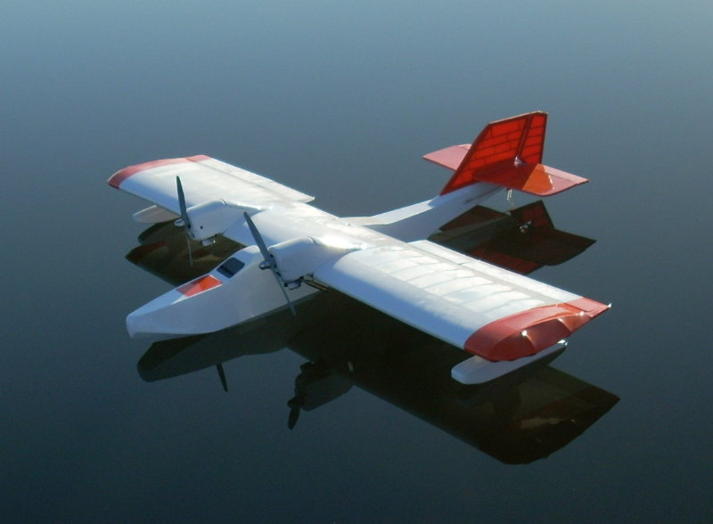

This is the Sea Plane I have been working on for about a year.

It has a 7 foot wing span, and is powered by 2 Saito 50s.

Chick Foster

WITH THE WEEKDAY WARRIORS November 2008

Even with rotten weather preventing us from flying on many days, the grass isn’t troubled at all. It still grows. So Doug McWha and Jim Corbett are still out there mowing between showers. Doug was startled one day when he turned into the road to the field and saw that the strip was white from end to end. No rain and nowhere near cold enough for snow or frost. Spider webs. Those little flying spiders were staging a major convention on our field. Don’t anyone tell the Buggies’-Rights people, but Doug just mowed it all off anyhow.
There have been a few new models showing up at the field on the few decent days we’ve had in the last four weeks. Marty Whittman brought out a Twist 150 in which he’s using a Zenoah 26 for power. He’s used a number of Zenoahs of various sizes and swears by them. Does that “26” mean 26cc? If so, it would be a 1.59 in real measurements.
Chick Foster’s new one is a 4-Star 60 he’s powering with an ASP .61. Needed a little carb-fiddling on the day I saw it, but I seem to remember that all was well in the end. The ASPs were copies of the equivalent O.S.s and this one is like the FSR series with the separate frontplate. Separate frontplates are nice, if you build a pusher. You can get the engine to run clockwise, and thus use regular props, by rotating the frontplate 90 deg. Pusher props can be hard to find, especially if you need a particular diameter/pitch.
Lewayne Thompson brought out a high-wing trainer (Avis¬tar?) with a Spectrum 2.4 gig radio. Lacking a buddy box compatible with a Spectrum, he and Jim Corbett made do with the old method of passing the transmitter back and forth -sometimes rather hurriedly. The plane got out pretty far a few times and may have been the UFO sighted over Corvallis that day, but all seemed to be well at the end of the inning. After that, The Brain Trust, Jim and Doug, got out the instructions (extraordinary idea!) and discovered that there is a way to make Spectrum and Futaba transmitters cozy up to each other. It involves taking the RF module (or crystal) out of the Futaba you’re using for a buddy box.
Don Desimone’s still flying his Funtana 100X. Don hasn’t done anything remarkable with it, hut I had to get him in this column to make up for the absolute dog’s breakfast I made of his name in last month’s.
Jim Corbett made an incidence change in his electric Lanier Stinger and it seems to have helped. The thing still bounces something awful on almost any landing and Jim has concluded that the landing gear is just too stiff. Yes, Doug McWha’s EasySport still graces the field regularly. Or is that “disgraces”? It’s starting to assume its pre-repair rattiness. Mr. McW brought out his Tango on one very calm day. This is a high-winger with a low-aspect-ratio, constant-chord wing married to a short-coupled fuselage and tail surfaces which are fairly gracefully curved. The engine is an O.S. .46LA, one of the blue ones, but Doug’s is so ancient that most of the blue is worn off. He had the F-22 Raptor out today (11/17) with the cuffs back on the outer wing panels (with masking tape!) and it seemed to fly well after a change of prop size. The nosewheel cable has a wee bit too much unsupported length and this let the horn flip over to the right. This left the Raptor up at the far end of the runway with the nosewheel at 90 deg to the model and Doug with a long walk to retrieve it.
That huge Yak 54 Pat Willis flies so much has undergone some adjustment to the balance to make it fly even better. It did land on the Monday with fuel sloshing around in the bilges because the stopper had come out of the fuel tank. No harm done and more flights ensued that day. The next day, things took a nasty turn. Pat took off and, in his usual fashion, put the Yak’s nose straight up - at which point the engine quit. The subsequent arrival was somewhere between a

WITH THE WEEKDAY WARRIORS November 2008 continued

hard landing and a crash. Damage was done to the cowl, firewall, and landing gear as well as one of the big horn balances on the elevator which dug in and was almost torn off. Broke a prop - which was probably worth more than the total I had in the two Rubber ships I had with me that day. Cause? Ouch. Even powerful, reliable engines like 3W 85XIs really, honest-to-gosh need fuel to run and Pat had forgotten to refuel. I’m told the Yak is back in the air already.
Farrell Bird now has a Hangar 9 Ultra Stik like Dave Simmington’s and Farrell has a Saito 100 4-stroke in his. He and Pat did a fair old amount of engine fiddling before the latter made the test flight. Flew fine, but all the foam rubber padding the tank and battery
pack were fuel-soaked upon landing. Tank plug out. It seems to be epidemic - watch yourself.
Mel Graham’s tank plug didn’t come out, hut the glassfibre landing gear on his Extra has started to delaminate. How many times have you seen that? Your columnist has had his Aquila sailplane up and the best he can say for his flying is that he never beat the launch-line to the ground. And one of those days was pretty sunny and I should have found some lift. The field to the north of us is not yet too muddy to lay out the high-start, so there’s hope for at least one more thermal before it does.

C.O'D.

Treasurers Corner

Al Barrington reported we have 105 members in good standing as of the end of October. Just a reminder - it's membership renewal time again!

KUDOS

Doug McWha - Thanks for your effort as our Groundskeeper.
ERCA Club – My wife and I enjoyed the Gift Card for dinner at Chapala’s, we want the membership to know we appreciated it. Jim Corbett

For Sale

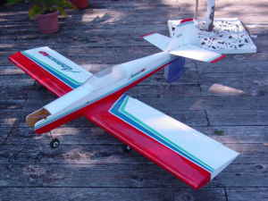
Hangar 9 Advance 40

Structurally sound, a few small bumps, no
electronics but has a fuel tank. $75 or trades
for gear.

I can be contacted thru this e-mail
donddr@yahoo.com
or by phone, 915-4408.

At the field November 13

A few of the aircraft that flew Thursday.

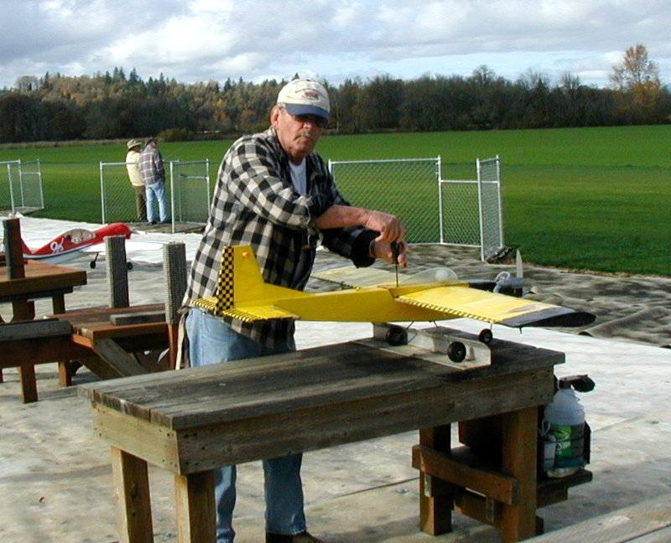

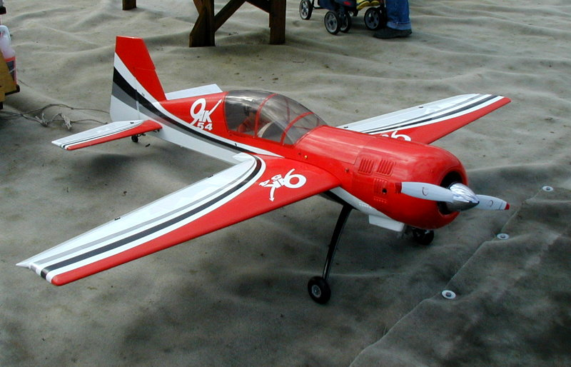

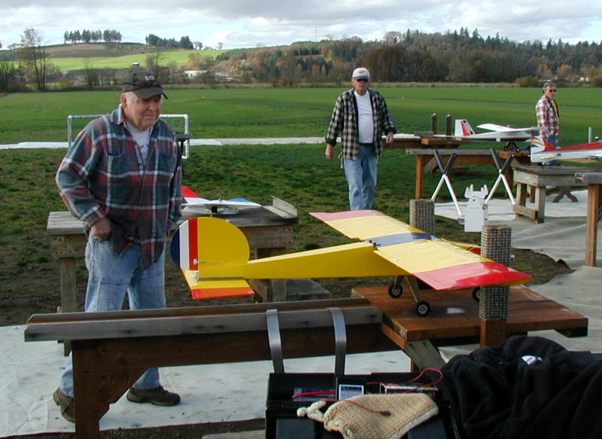

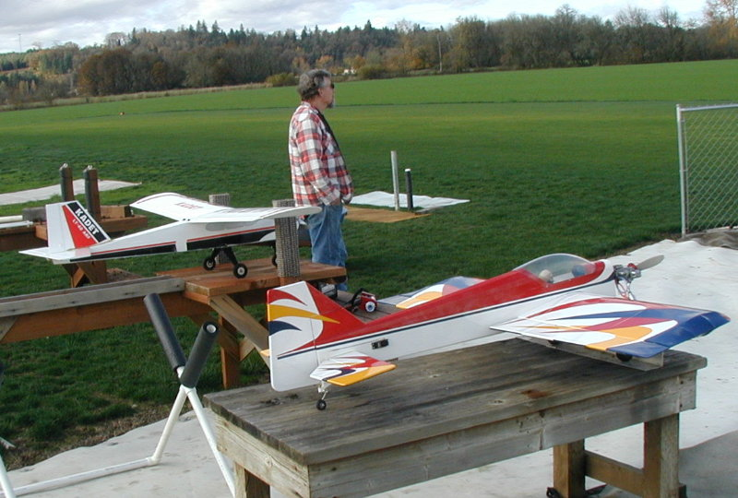

Field Improvements Big Bird Restraint System

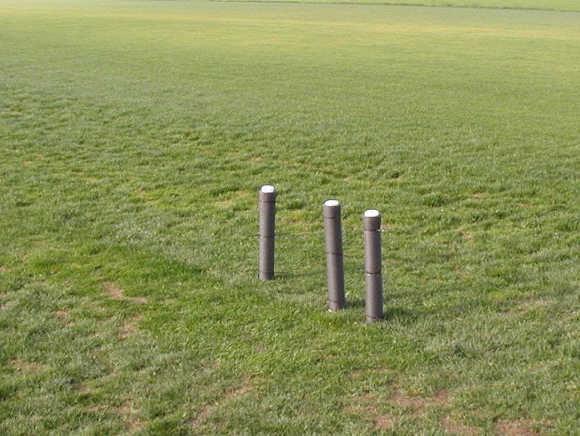

Three removable padded posts.
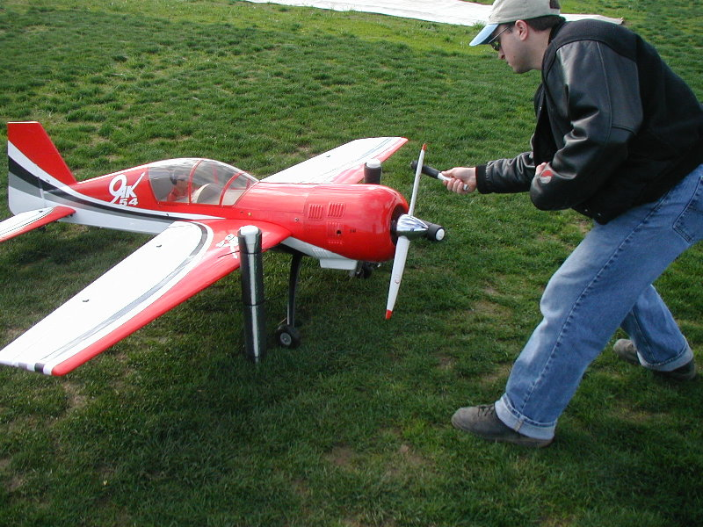

Restraint system in use.

Technical Review by Greg Knecht

Cellmeter

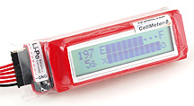
For any of you out there using Lithium batteries here is a gadget that I’ve used the past 6 months and found absolutely invaluable. The “Cellmeter” offered by Hobby Lobby, connects via the balance taps to your battery and gives a readout of percent charge, cell balance, and individual cell voltage of each cell in the pack to a thousandth volt.
How many of you have mixed up the discharged lipo with the fully charged one and suffered the consequences of an immediate dead stick?? Well I have on more than one occasion and this quick and easy meter has nearly eliminated that dumb mistake. Also, as I think everyone knows, the balance of each cell is absolutely important to prevent over discharge of individual cells, which effectively destroys the pack eventually.
Though there are different cell balancers out there, they don’t give you the “visual” of what the cells are doing which I have found really helpful. By conveniently checking your pack before charging you can balance it with a “Blinky” (Astroflight), or other cell balancer and prevent the progressive destruction of your battery. By checking after the charge you know you are fully charged and balanced for your next flight.
My battery lives have been markedly prolonged which is a good thing since they are so darned expensive! There is a bar graph display on the meter which gives you the percent remaining “in the tank” and by checking that after a flight you might be surprised at how much (or how little) you have left-both very helpful in setting your timer on future flights. If 30% is still showing after a flight, and I had set the timer for 10 minutes, then I reset for 2 or 3 minutes and have another go around. After a while you actually start having a more visual love affair with your batteries!
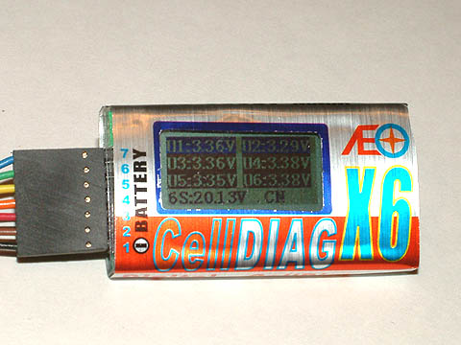
The down side is the expense-a hundred bucks or so, though I just saw one with lesser whistles and bells for $29.99, made by Innov8tive Designs. No personal experience with that one at all but I plan on getting one soon and will give you an update on that more affordable one.
Check em out!
Greg Knecht

Sharing Channels

The 2.4 GHz R/C Revolution (part 1) by Patrick Willis

DISCLAIMER: I make no claim to be an expert, but I've learned a few things over the years. Anything I write is my opinion based on my experience. Take it for what it's worth and feel free to disagree. -Pat



About three years ago now, a little-known company came out of the woodwork and presented a 6 channel short-range park flyer R/C system on the 2.4 GHz band. Suddenly, all the big names realized that they needed to act quickly and produce something better. However, while they were still scrambling to get a single system out on the market, the same little company came out with a full-range 7 channel computer R/C system on 2.4 GHz. Their advertisements used terms such as "bullet-proof" to describe the radio frequency (RF) link between their transmitter and receiver. The hype started to overwhelm all the internet forums and it seemed everyone was trying to find out more about this new technology.

There are four major players in the 2.4 GHz market today. The "little-known" company was Spektrum R/C, who partnered up with JR, and together they have dominated the 2.4 GHz market. Second place goes to Futaba, who entered the market very late and, as a result, lost some of the loyal fans to Spektrum/JR. Third goes to XPS, who makes 2.4 GHz modules and receivers that sport features that none of the other players have. At a distant fourth place we find Airtronics, who despite their name has been concentrating on surface-based systems for the past several years.
There are other brands that have come out in the past 6-9 months, but none of them have taken a very strong position in the market. Those brands are Assan, Corona/BP, and a few others whose names escape me. Assan is a module based system sold by Hobby City (China). I've read very mixed reviews on the Assan systems and I would not recommend them to someone wanting to fly anything bigger than a park flyer. I don't know enough about the other small players to make any comments.
All of these systems use different proprietary communication protocols and cannot communicate with each other. They also are not allowed, legally, to actively interfere with each other and must be able to "play nicely" together, even when sharing one of the 16 channels that are used for R/C in the 2.4 GHz band. Yes, that's right, they will be on the exact same frequency sometimes, and they must share it.
So, let's start with número uno: Spektrum/JR. Yes, that's right, they're basically the same thing. They are two different companies that partnered up to take a very firm grasp on the 2.4 GHz market utilizing the Spektrum DSM and DSM2 technologies in the existing JR radio systems. Using a lot of advertising hype telling you that you will "never get shot down again!" if you use their system, Spektrum very successfully marketed their DX6 park flyer system, and then later their very popular DX7 full-range system. You can find a few DX7's at our club field on a regular basis.

Sharing Channels continued

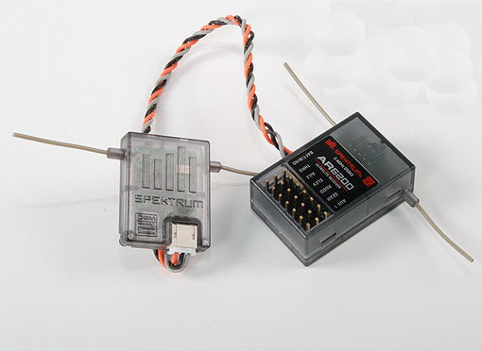
Spektrum now sells the five channel DX5e and six channel DX6i, both of which are full-range. JR sells the X9303 and 12X systems with the Spektrum technology on board. JR/Spektrum systems employ satellite receivers that connect to the main receiver, giving signal redundancy. When the system powers on, it boots up like a small computer and locks onto two open channels in the 2.4 GHz band.
Spektrum/JR users learned early on that, unfortunately, there is no such thing as a bulletproof RF link afterall. Reports of inexplicable interference on the supposedly immune 2.4 GHz band came pouring in. How could this be? And, then there was the low voltage re-boot issue. As it turns out, using high-torque digital servos can make your on-board battery pack's voltage spike below the Spektrum receiver's minimum voltage and cause it to momentarily turn off and turn back on again. The problem was that the receiver needed time to re-boot, (think about your computer at home when you turn it on and wait for your desktop to appear). During that time, aircraft came crashing down.
Your humble writer's opinion is that the advertising was misleading as far as the ballistic properties of the RF link go. There is still interference on the 2.4 GHz band. Yes, it's true! I would say there is usually a lot less interference from on-board components such as ignition units, electronic speed controllers, and metal-to-metal contacts such as clevises and pushrods, sparkplugs, etc. rubbing together. However, there can still be environmental factors such as Wi-Fi devices and some types of radar systems. Luckily, our club does not have to worry about such things in our rural location. The main interference actually is only indirectly related to the receiver. You see, people found that the interference from on-board equipment was actually traveling through the servo wires directly to the servos. The receiver was often bypassed completely by the offending RF interference (RFI).
Spektrum/JR, like any company out there would do in such a situation, basically said, "Hey, use an appropriate power system in the first place to avoid lock-outs, okay?" The low-voltage re-boot issue was eventually addressed in a more technical manner and all new receivers came with new firmware that included a lower voltage tolerance and a much quicker re-boot. The interference issue was a result of people not adhering to the old principles of clean installations, for the most part, and were usually pretty easy to resolve.
Before Spektrum/JR was able to mass-resolve their low voltage re-boot issue, however, big name #2 came out with a system they said they'd been working on for many years.

To be continued in the next newsletter...

GLOSSARY OF TERMS Source: http://www.spektrumrc.com/DSM/Technology/glossary.aspx

Flying Experience by Raleigh Williams

Saturday, Oct 25 was another beautiful flying day. Rich Richardson called me and suggested we go flying. I was easily convinced that it was the thing to do. We met at Amazon Park, a nice place for electrics. Rich had his magnificent slow-flying bird, I brought my often repaired Stick.
Rich flew first. Take-offs, landings, flying, everything he did looked perfectly planned and executed.

Flying Experience continued

I thought I'd move the battery of the my Stick a little bit aft to bring the CG closer to the "correct" place. Seemed OK when I checked the balance before flying.
When I took off, the Stick went straight up. I got the nose down. Rich yelled "reduce power", which I did. It immediately became more controlable, but I had to hold forward stick to fly level. In the meantime, I was not being very attentive as to where the plane was. Next thing I knew, I had executed one of my best landings ever, right in the top of one of the tallest trees around. After looking at it awhile, it became clear that it would not come down by itself. I tried begging the tree to release its hold, but it refused.
Rich noticed some college students nearby tossing frisbys. He suggested I ask one of them to climb the tree and rescue my plane, which I did and which the frisby player climbed. It looked like a very tough climb to me, but the young man scaled it quickly. After shaking some branches, first the wing, and then the rest of the plane dropped to the ground. He climbed down without a scratch on his bare legs. I thanked him and gave him a small reward. Rich gave him the big reward by letting him fly his marvelous airplane. The student had never done it before but he caught on right away. A talented young man for sure.
I'm embarrassed to admit that I seem to be a perpetual beginner with models. Both Jim Corbett and Rich have often warned me to stay away from trees. This was my first tree, and I was lucky to get my plane back. In the past I've hit a goal post and made lots of crash landings. My Stick is getting heavy with all the glue it's wearing.
I'm 80 now. Maybe when I mature a bit more I'll be able to master the art of flying models.
Raleigh Williams

ERCA CLUB CONTACTS

President: Pat Willis – 543-8999 - p-willis@msn.com
Vice President: Mel Thompson - 746-5699 - met324@comcast.net
Sec/Treasurer: Al Barrington - 935-4960 - albarrington@msn.com
Groundskeeper: Doug McWha - 741-3326 – flyduke@comcast.net
Field Marshals: John Bowhan - 607-5752 - jbowhan@epud.net
Frank Blain, Jim Corbett, Bill Hollingsworth, Khoi Tran, Alan Wellentin
Newsletter Editor: Jim Corbett - 344-5022 - james.corbett@comcast.net

Next CLUB Meeting – November 25, 7:00 pm at EWEB.

--- That's All Folks ---

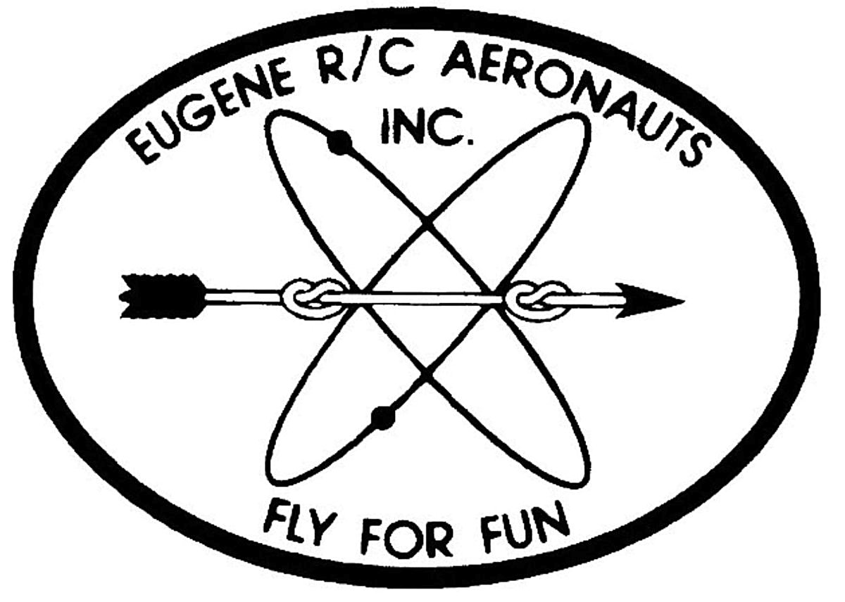
Eugene R/C Aeronauts
Newsletter Editor
1618 Gilham Rd.
Eugene, OR. 97401

NOVEMBER 2008

Name

Address
City, ST Zip

___________________________Renewing Current Member____________________________

INVOICE FOR 2009 MEMBERSHIP - EUGENE R/C AERONAUTS

Please fill in the following information and send back with your Dues Remittance

Member Name __________________________________________________________________

2009 AMA Membership No.________________________

I certify that I have paid my 2009 AMA Dues. Initial _________

Member Address _______________________________________________________________

Member Phone No. __________________________

Member Email Address __________________________________________________________

Newsletter Preference: ____ Email ____ Regular Mail ____ Do not need to receive newsletter

Please enclose your check for $ 60.00 as a current member renewing for 2009 and

Mail to: Eugene R/C Aeronauts, PO Box 50034, Eugene, Or. 97405.
Or bring this INVOICE and $60.00 to the Meeting, November 25, 7:00 pm at EWEB.

Newsletter ONLINE at: http://eugenerc.com/NL/CURRENTNEWSLETTER.pdf

