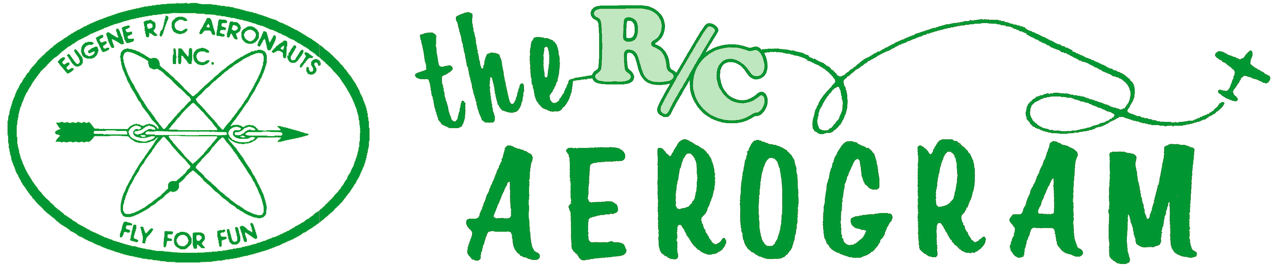

Volume 4 Issue 10 AMA #530 District 11 www.eugenerc.com October 2008

Club Mailing Address: Eugene R/C Aeronauts, PO Box 26344, Eugene, OR. 97402

ERCA News and Information

Next CLUB Meeting – October 28, 7:00 pm at EWEB. If you have a building project, bring it with you for "Show and Tell".
At the September Meeting – There were 14 members and guests at the meeting.
The proposed north-south’ish runway, to be used in heavy cross wind, experienced a fatal blow. The farmer has denied our request for a “bump out” along the northern edge of the current runway, citing difficulties associated with cultivating around the odd shape.
We will shoot for a July date for next year’s ‘Fun Fly’ event.
Al B. was awarded a gift certificate in appreciation for his hard work.
The mats covering the ground in the pits are shrinking, wrinkled and have rolled edges. A consensus was reached accepting the wrinkling was better/safer than the mud pit of before.
A reminder to all……….only two meetings left this year, start thinking about nominations for the elected club offices.
Regarding repairing broken propellers. President Pat Willis made it clear to our membership that re-using propellers that had been broken was an unsafe practice and is not permitted. If a by-law needs to be made to that effect, it will, but would hope it is not necessary.
The merit of filling in the low area along the south side of the runway, west of the club house, was discussed. A ready supply of fill dirt is available for only the cost of transporting. Everyone seemed to be in agreement that the leveling of the area in question is a good idea. A decision was put off until an economical method of trucking the fill in can be identified.
Once we get a little rain and the ground softens Doug and crew are going to sink some pipe at ground level near the east and west end of the pit area. The pipe will accept uprights that can be used for run-up anchors for extreme scale planes.
Show &Tell - Jacob B brought his new mid-sized Yak.
----------------------

Do you have any ERCA related photos you would like to share?

If so pass them along PLEASE!
Email, snail mail or leave them on the bulletin board in the club house

----------------------

Meeting minutes are ONLINE at: http://eugenerc.com/meetings.html

Presidents Corner

I'm writing this month's contribution in a state of sleep deprivation in order to make sure I turn it in on time, so if I ramble or make odd statements, I'm blaming that.
First and foremost, please consider running for your club's E-board for next year. If not you, then please think of someone who you think would make a good officer for the club. It is not a huge, life-altering time commitment, nor is it an enormously stressful experience. We have plenty of members who are able to fill the positions, and you are probably one of them. Do you think that paying your dues is enough? I've heard that from plenty of our members. What if everyone felt that way? Would Doug McWha be out there mowing, watering, cleaning, and doing all the little Doug-things that Doug does? Would Jim Corbett be maintaining the web page, creating the newsletter, maintaining the lawn mowers, and all the little Jim-things that keep Jim busy? Would Al just be paying his dues instead of keeping our treasury meticulously documented and our bills paid? If Frank had felt that way, would we even have a field? I could go on, but I think you get my point.
Go to the October meeting and nominate someone for office, or nominate yourself!!
The turn-out for the September meeting was very sad. We've tried incentives such as raffles, door prizes, etc. in the past, and I've decided that at the next meeting with a low turn-out, I'm going to bribe the members present and have someone make a motion for a Presidential salary, which will unanimously pass, of course, and then I will start receiving a paycheck. Thank you in advance for that. Seriously, please do your best to make it to as many meetings as you can. I hear from people frequently about the motions that pass or fail and how they want one thing or another for the club. There's only one way to make that happen, and despite past practice, there is nothing in the by-laws about a proxy vote or absentee vote being acceptable for any club business.
Starting next year, I've agreed to write a monthly column in the newsletter with stories, tips, tricks, etc. I am by no means a huge wealth of information, but I was asked to continue to contribute after my term in office, and I may have some things to share given how much I read about how to build, balance, modify, construct, snap, slip, flip... again, you get my point. Our newsletter editor says that he would like more content to give the readers, and since I like to write, it may work out just fine. I'm no Chuck O'Donnell, (there is only one!) but hopefully it will be better than nothing!
I've had a lot of people ask me about 2.4 GHz, since I fitted my Futaba 9C system with the XPS module and receivers. I'm happy to report that in the year that I've had it I have had no issues with the exception of one receiver failing to respond, (on the ground, during pre-flight). That receiver was replaced at no cost by XPS.
I have also seen that Airtronics is trying very hard to get back into the airplane market with their 8 channel computer radio on 2.4 GHz. This is a dedicated full-time frequency hopping DSS system that is, perhaps above all, very affordable. They are selling the radio system with two receivers for a mere $229.99 through Hobby People. If you have thought about upgrading, this may be a very good time to do so. Futaba's receivers are also becoming more affordable, and the Spektrum equipment is abundant and proven. I plan to do my first technical newsletter contribution on the 2.4GHz

Presidents Corner continued

trend and what it means to you, the consumer, with a comparison of the mainstream systems out there.
My 1/3 scale Yak is back and now sports a 3W85xi turning a Xoar 27X0 prop. Even at this early stage in the break-in, (gas engines take 2-4 gallons to fully break-in) with only six tanks of fuel through it, the power is fantastic. No, it's not overpowered according to the manufacturer, this is just the top-end of the recommended engine range. Is it overpowered according to rational, reasonable people? Um, YES! And, it's a lot of fun that way for crazy pilots like me. I've also upgraded the tail servo to two Hitec 5955TG's (333 oz./in. of torque on each) on a metal tray with a bellcrank to take the pull-pull cable tension off the servos. The rudder now can flap back and forth like a fish's tail with its diabolical 666 oz./in. of torque on the rudder alone.
Until next time, may your rolls be axial and your loops round...
I'm writing this month's contribution in a state of sleep deprivation in order to make sure I turn it in on time, so if I ramble or make odd statements, I'm blaming that.
Patrick Willis
ERCA President 2007-2008

Treasurers Corner

Al Barrington reported we have 104 members in good standing as of the end of September.

KUDOS

Doug McWha - thanks for keeping the grass GREEN and SHORT all summer. Now mother nature can assist you with the watering.

If you haven't yet checked out Jim's re-vamp of the website, I suggest you check it out.

Jim, I commend you for your excellent work on the site. I have thoroughly enjoyed looking at all the new pictures and other content that is constantly being added. The website is evolving all the time, just as it should be. With your hard work, I think we have the best club website in Oregon!! A job well-done.

At the field - October 10

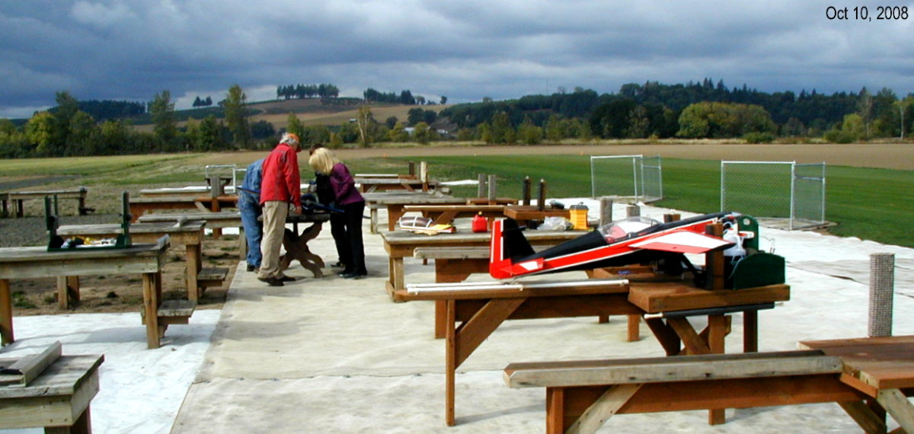

Serious advice
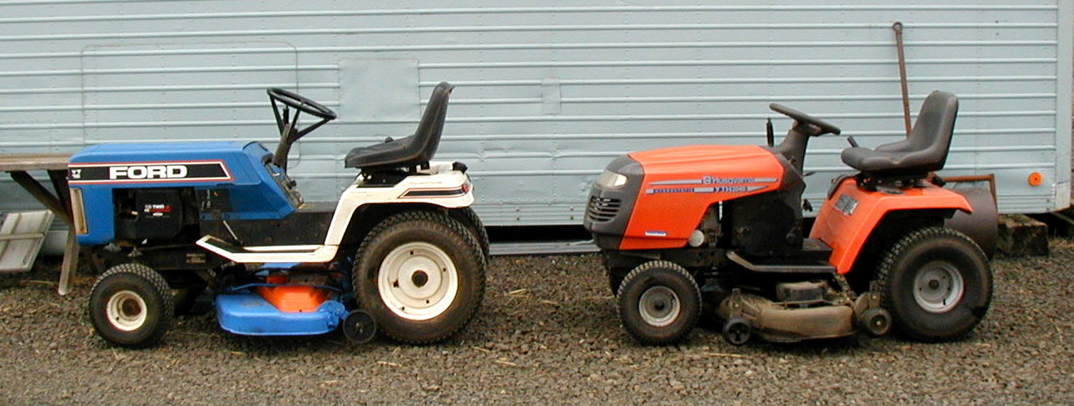

Club house and mowers washed

WITH THE WEEKDAY WARRIORS

Ugh! It looks like becoming The Gray Pathetic North - left again. Fog, drizzle, sprinkles, showers - - that other nine months of the year is now upon us. Soon there won’t be enough flying weather for me to find anything to warrant a column.
Oct. 4 & 5 saw the last contest in this year’s Free - flight Season, so your columnist was free to qualify for an appearance in his own column by flying R/C on a weekday. I had the old Aquila sailplane out on an overcast Columbus Day and the results weren’t really newsworthy: Three flights, good launches, no lift. Jim Corbett, your Editor, was flying his light, electric, Stinger and he did find the tiniest bump of lift, but that’s all it was - a tiny bump. Before too long, that field in front of us will be too muddy to lay out the high-start, so I’m flying the sailplane while I still can.
Vern Wells flew three flights with his Avistar and flew them all on his own. Chuck Jenkins was not even present for moral support. All three landings were, at least, respectable and one was very smooth. Wayne Wahrmund was up at the field on the same day, flying his regular LT-40, and I asked him how his U -Can -Do was coming along. “Oh”, he said, “The second one? It’s almost ready to fly.” Whoops, wait a minute! Second one? Here I go away for a couple of weeks and all sorts of things take place behind my back. It seems that Wayne’s first U-C-D had a short life, ending in trage-dy. Wayne had mounted all the radio gear just right - with only one small exception: He neglected to uncoil the receiver antenna and stretch it out through the fuselage. Now you know what happens in that case. The radio signal enters one end of that coil and goes whirling around. By the time it reaches the receiver, it is so dizzy and con-fused that it can’t remember what to tell it or, worse, tells it wrong. If I’m understanding correctly, the poor plane didn’t make it past the initial 180 deg turn after takeoff. Wayne says the wing came out with hardly a scratch, so there’s at least a little good news. Mr. Wahrmund says, by the way, that he’s hanging on to the LT-40 just because it’s such a comfortable aeroplane to fly.

Don Delamore has been flying a Funtana 100X with an O.S. 160 2 -stroke. Don admits that it is “a bit more engine” than the plane needs, “But, if I build a bigger plane, I’ll have an engine for it”. The “X” version of the Funtana has a higher -aspect-ratio vertical fin and tip fins on the wing which attach with two screws each. Don has tried it with and without the fins and is not ready to brand either way as best. The fins seem to make the plane more stable, but slow the rate of roll.

The other half of the team, Brian Ropchan, also had a Funtana, but an older-model 40-size machine. He’d shown remarkable restraint In powering it with a mere .46, an 0.S. FX model. Very strange to relate, this one lost its prop in flight, not an uncommon occurrence with 4-strokes, I’ll grant you, but this was a 2-stroke. Brian had to put down the Funtana in the rough field and tore out the landing gear - the only damage. Even the spinner and prop were visible out in the dust and easily recovered. Then it was noticed that the drive washer was also missing. “Washer” is a bit of a misnomer as it is a pretty thick piece of machined metal. Brian says he has another .46 with a bent shaft which can donate its drive washer to the Euntana’s engine. I still have a few more freeflight tests to do, even with the season over, and, who knows, I may find Brian’s engine part. I am told, by the way, that the battery pack I found under those circumstances was, indeed, Dave Simmington’s. Brian wasn’t through for the day. He hauled out an Ultimate 120 bipe (another 0.S. 160) and flew that for the rest of the day.

WITH THE WEEKDAY WARRIORS continued

President Willis gets out to fly with the weekday crowd. When you are President of such a prestigious organization, even employers (Pat’s is the City of Eugene) see the Greater Good for the Community in turning you loose on the flying field. Pat is, of course, getting all his time in on that vast Yak 54 and it now has a new engine. The new one is a 3-W 85xi. I do not know what the “xi” stands for (xtremely impassioned?), but it does indicate that this engine is not your Aunt Clara’s 3-W 85. It is meant only for those who wish to point the noses of their Yak 54s vertical and contact space stations. You will see Pat making beautiful, perfect 3 -point landings with the Yak from here on. He has to. The 85xi swings a bigger prop and ground clearance is now measured in nano-cat’swhiskers.
I mentioned having been away. I took a trip back to the Auld Sod (Sussex County, N.J.) and looked in upon the flying fields of the Top O’ N.J. R/C Club of which I was a member before it was even that club. I even attended one of their meetings which was no worse than ours usually are. I had some pictures I had taken on our field and the one that most impressed them was one of Pat starting his Yak with Alan Wellintin holding. It wasn’t the plane nor Pat, nor Alan that impressed them, though they admitted it was a fine plane and two obviously handsome fellows. What opened their eyes wide was the vast expanse of flat, treeless, ground visible beyond them. In Sussex County, there would be a couple of forest preserves, a town or two, and a swamp in that space.

C.O'D.

At the field - September 19

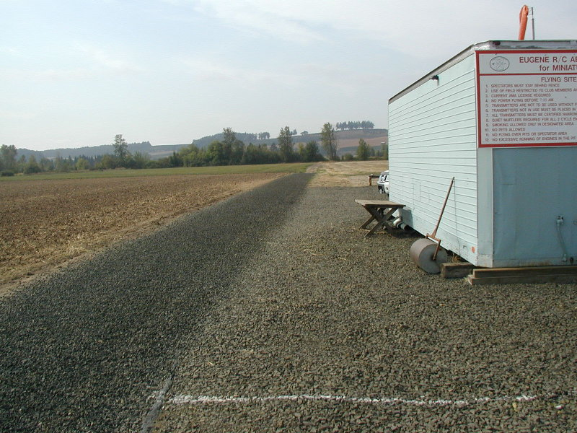

Fresh gravel on road

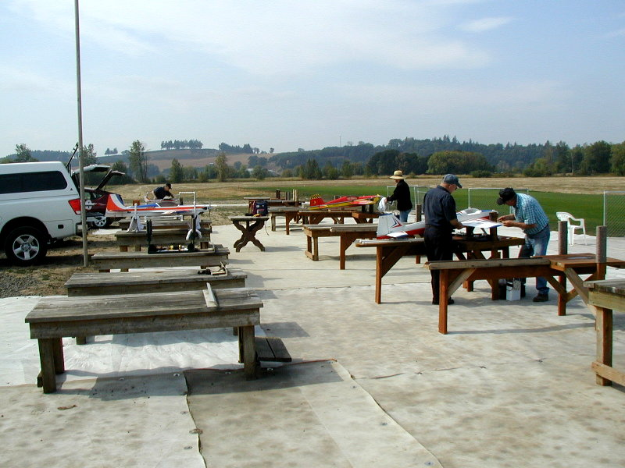

Busy pit row

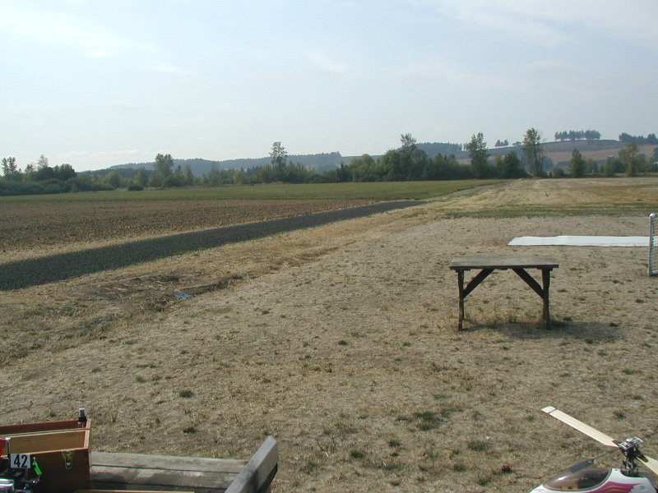

Gravel extended west

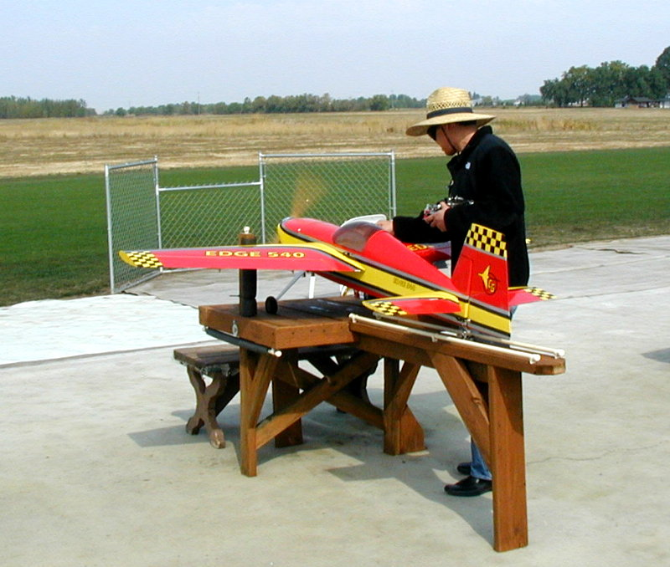

Fine tuning

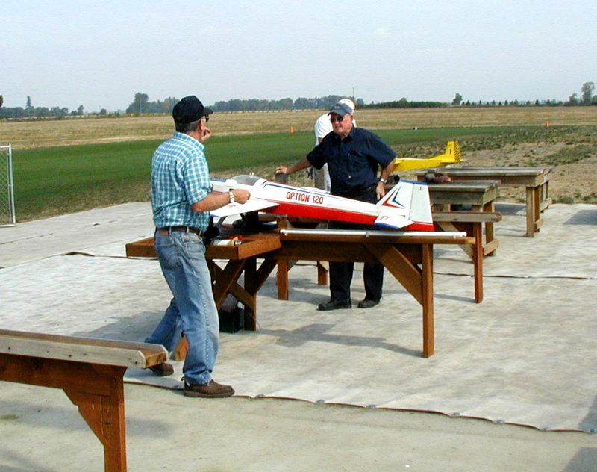

Thank you! It was a nice landing

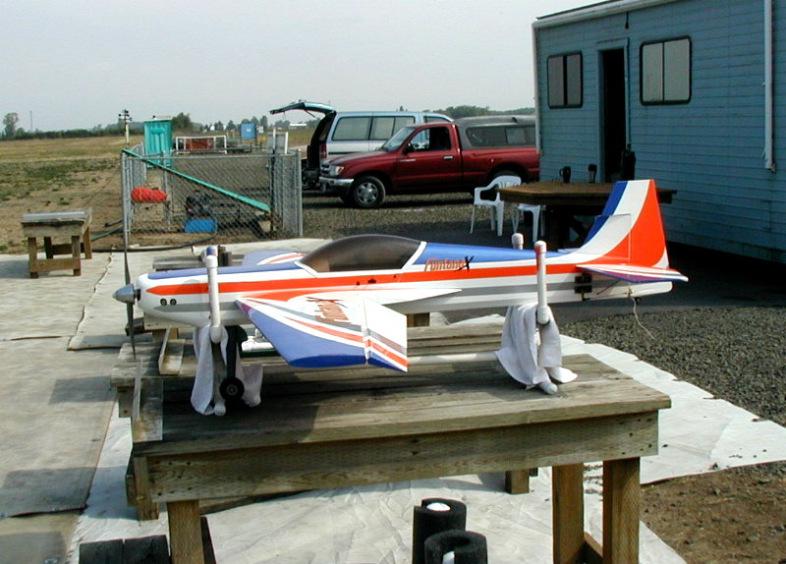

How long before my turn?

--- That's All Folks ---

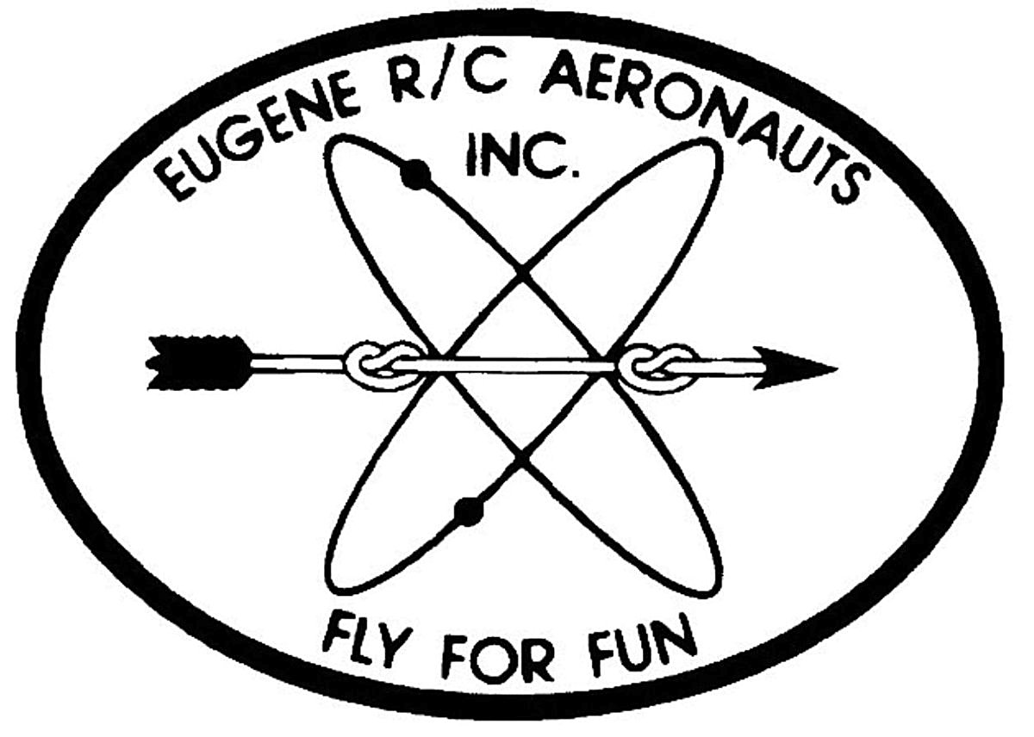
Eugene R/C Aeronauts
Newsletter Editor
1618 Gilham Rd.
Eugene, OR. 97401

OCTOBER 2008

Name

Address
City, ST Zip

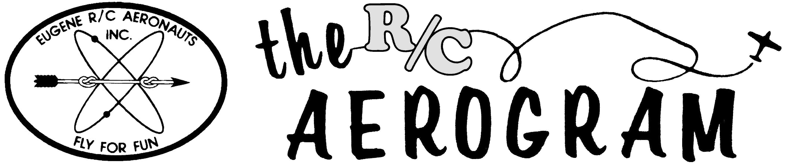

ERCA CLUB CONTACTS

President: Pat Willis – 543-8999 - p-willis@msn.com
Vice President: Mel Thompson - 746-5699 - met324@comcast.net
Sec/Treasurer: Al Barrington - 935-4960 - albarrington@msn.com
Groundskeeper: Doug McWha - 741-3326 – flyduke@comcast.net
Field Marshals: John Bowhan - 607-5752 - jbowhan@epud.net
Frank Blain, Jim Corbett, Bill Hollingsworth, Khoi Tran, Alan Wellentin
Newsletter Editor: Jim Corbett - 344-5022 - james.corbett@comcast.net

Next CLUB Meeting – October 28, 7:00 pm at EWEB.

Newsletter ONLINE at: http://eugenerc.com/NL/ CURRENTNEWSLETTER.pdf

